|  |
| --- |
| **UPMC Pharmacies**  **User Test Report**  **Dated**  **10/30/2017** |

|  |
| --- |
| **Prepared By Approved By**  **NAME Team 4**  **SIGNATURE**  **DATE** |

#### User Test Report

**Table of Contents**

**Topic Page No.**

Brief Description of Users 4

Process Overview 5

Feedback & Critical Incidence 22

|  |  |
| --- | --- |
| Brief Description of Users |  |

* User 1 (old user)

The old user is a 57-year-old lady with moderate online shopping experience, which let her quite familiar with online shopping process. To be more specific, she uses Amazon twice a month. However, she has never tried online pharmacy yet. Also, this lady majored in English so she is very sensitive about the wording. Besides, her daughter is a CMU undergraduate student.

* User 2 (young user)

**About the user -**  The user is aged 22 and is pursuing his Master’s in Computational Data Science at CMU.

**Skill level in using the web -** Proficient.

**Reason for selecting him -** As somebody who works on Machine Learning, he brings a unique perspective to the table in that he critiques elements (like product recommendations, “related categories” sections, etc. that we implemented in our prototype) in ways that are not obvious to the eye. Also, the user is quite observant and clear headed.

|  |  |
| --- | --- |
| Process Overview |  |

**Before the interview:**

1. Introduce ourselves and the task

2. Give introduction about this interview and get the recording permission

3. Ask if there is any question before the interview.

**<Preliminary Behavioral questions>**

1. Do you buy medicine by yourself? Do you buy for other family members or friends?

2. How often do you buy medicine?

3. Have you bought drugs online? If yes, how often?

5. When would you find yourself using online pharmacy?

4. Which website do you use most? Why do you choose these websites? What is your feeling about shopping on these websites?

6. Would anything influence in your decision-making?

**First Impression:**

1. What is your first impression of the website.

2. Can you give us 2-3 words to describe this website at the first sight before using?

**Tasks:**

**There are two tasks that need you to complete:**

**1.** **Buy a vitamin C product using this website.**

**2.** **Buy a cold/fever product without using the search function.**

**<1> Homepage**

**Possibility one: Search by product name/brand**

1.1 Why do you search this product/brand? Is this product/brand very familiar with you in your daily life?

a. If you do not know any specific product, what are you going to do?

b. Why do you choose to type in rather than using navigation? / Why do you use navigation rather than type in?

**Possibility two: Use navigation**

1.1 How can you find the navigation function? Is it easy for you to find it?

1.2 What do you think about this navigation bar?

a. Is the category classification very clear?

b. Can you quickly and precisely find what you need under the right category?

1.3 How do you find yourself when you get lost in the website navigation structure.

1.4 Does anything in particular catches your eyes while navigating in a website and may or may not change your behavior?

**<2> Category/Search Result Page**

2.1 Is the category divided clear? Can you find the medicine needed under the category?

2.2 How do you feel about this result? Do you find the medicine that you need?

2.3 Are the search results too vague/irrelevant? How can you narrow down your search?

a. If the user uses the filter:

i. Why do you use this filter.

ii. Is it helpful?

iii. Is there any other filter that can help you that is not here?

2.4 Can you decide which one that you are going to click into? And why.

**<3> Product Detail Page**

3.1 What kind of information that you want to know here?

3.2 Can you find this kind of information you need from this page?

3.3 Where did you expect it would be? (From where you look for first?) And where it is.

3.4 What else information that you think may help you here?

3.5 Are you satisfied with this result?

a. Possibility 1: Yes, this is exactly what I am looking for.

i. Are you going to buy this product? What you will do next?

ii. What made you confirm that this is the exact drug that you are going to buy? (Drugs Fact? Picture of product?)

b. Possibility 2: Well, I am not sure. I want to explore more products.

i. What made you feel this uncertainty? Is there any information missing or too vague?

ii. What you are going to do? (keep this page or just put this product into the cart first)

c. Possibility 3: No, I am not satisfied at all.

i. What made you click into this product?

ii. What made you feel you are not going to buy this one?

**<4>Cart\Checkout\Confirmation page**

4.1 Is all the information clear on this cart page?

4.2 What is the next step?

4.3 Could you try to complete the address form?

4.4 Do you still have any concern or hesitation before you confirm this order?

4.5 Is there anything that makes you confused on this page?

4.6 What do you think of the all payment process?

**<5> Registration/Sign in page**

(To do the payment, the user must register first. But the user may also sign up before they check out)

5.1 Why do you sign up?

5.2 When you are shopping at a new website, usually at what step will you sign up your account?

5.3 What do you feel about the register process?

(when error occur: miss match password/ wrong phone number…)

5.4 Since you have your account now, can you try the sign-up page?

5.5 Is there anything that makes you confused on this page?

**Overall:**

1. What do you think of this website?

2. Can you give us 2-3 words to describe this website after the trial use of it? And why.

3. Do you have any suggestion to help improve this website?

|  |  |
| --- | --- |
| **Transcript** | **User 1 (old user)**  1. Team4: We want you the test a online pharmacy website that we made. So, before the interview, we would like to know do you have any experience of online shopping?  2. User: Online shopping, yes. But for online pharmacy, no.  3. Team4: How often do you do online shopping?  4. User: Like twice a month. I will use websites like Amazon.  5. Team4: Before you have never tried online pharmacy before?  6. User: No. Usually my pharmacy at home has an app on my phone and that is how I order refills.  7. Team4: So, this is our website that we made. It is not a perfect completed version but just a prototype with several pages and it is designed for UPMC. We want you to try with this website and tell us about your experience and any suggestions that may help to improve.  8. User: Ok.  9. Team4: This is the homepage of our website. What do you think of this page?  10. User: It looks fine.  11. Team4: You can try these clicks here. There are all valid clicks.  (The user hovered above the navigation bar)  12. User: Yeah, I want to see what is different between personal care and medicine. Under the personal care, it is said throat/nose for personal care. But if you go here (Medicine), you will see “Cough, cold &Flu” and “Allergy & Sinus”. It might be confusing because it’s throat and nose, too.  13. Team 4: Oh, I see this problem.  14. User: You see, if you have a cold, cough, allergy or a sinus, you might need to buy throat and nose medicine but the throat and nose medicine is under personal care, too.  15. Team 4: Ok. So, what is your overall impression about this home page?  16. User: I think it’s fine.    17. Team 4: Now we have two tasks for you. The first one is that we want to you buy a vitamin c product on this website.  (The user went to the navigation bar very quickly.)  18. User: Go to the supplement. I think I need to click on this.  (The user clicked “Letter Vitamin A-K under the Supplement”.)  19. Team 4: Now you are in the category page.  20. User: Yeah, I see there is “Vitamin C” here. So, I click on it.  21. Team 4: So now it is the all the vitamin c products after you used the navigation bar at the homepage. What do you think of this result?  22. User 4: It was fine.  23. Team 4: Do you think this result is too broad?  24. User 4: You can group down by strength I think. Like you can group all the 500mg products together, and 1000mg together. So, if I want a low-dosage, I can find it first and when I scroll down, I can see the higher dosage.  25. Team 4: You can also use the filter.  26. User: Yes, but there is no filter by strength.  27. Team 4: So, we can add another filter for strength.  (The user pointed at two products)  28. User: And these two products do not show what its dosage is. It makes a difference. 500 is a lot less than 1000 and some people do not want to take that much vitamin c at one time.  29. Team 4: Did you notice this part? (sorting button) This can help you sort the result.  30. User: This one? (The user reads the sorting principles) It’s good! I like it.  31. Team 4: Did you notice this one when you were scrolling this page?  32. User: No, I didn't. It is too small. Maybe you could make it a little bigger.  33. Team 4: Sure.  34. User: And you know what, I would capitalize the letter “v” of “vitamin” and the letter “c”. Because down here (product names), it is Vitamin C. You know, to make it consistent.  35. Team 4: Thank you for your suggestion. And now you could choose one product, for example the first one, to go the details of this product.  (The user clicked the picture of the first product)  36. Team4: What do you think of this page?  37. User: You know, on some websites that have customer reviews, they will put an average rating next to it.  38. Team4: Okay.  (The user read the content of the page line by line)  39. User: You know, because it comes in different quantities, you may need to take that out (“100ct” of the name “Nature Made Vitamin C 500 mg - 100ct”).  40. Team4: Yes, to be consistent.  41. User: Yes.  (The user click to see the reviews.)  42. User: And have you guys seen some websites that have “favorable” and “unfavorable”, like a filter for the reviews. And you can see the highest rated and lowest rated reviews.  43. Team4: So that customers can see some bad reviews if they want.  44. User: Exactly. So, you can click that filter and it will straightly take you to see the lowest ratings or best ratings.  45. Team4: Here we have stars to let customers to rate the problem.  46. User: Oh right, here you go.  47. Team4: And according, we can add an average rating(stars) for this product on the top of this page, right?  48. User: Yeah.  (The user moved to the below related product)  49. User: Related products? Oh, it’s good.  (The user then clicked the other two columns besides reviews)  50. Team4: Now if you want to buy this product, what you are going to do?  51. User: So, I add to cart, right?  (The user moved to the “Add to Cart” button and clicked)  52. Team 4: Now you are on the shopping cart page.  53. User: Oh, I have Tylenol, too.  54. Team 4: Oh, it is just a prototype. Whatever product you add, it will go to this page.  55. User: Okay. And see, there is another one that doesn't say how many milligrams it has.  56. Team 4: Right, we will put on it.  (The user saw there is a “Continue shopping” button)  57. User: So, I can go back and continue shopping. Do you want me to continue shopping?  58. Team4: Oh yes. This time can you try the search function?  59. User: Type here?  (The user click the button, went back to the homepage and moved to the search box)  60. Team 4: Yes. So, you can find the search box very quickly right?  61. User: Yes.  62. Team 4: And can you try with Tylenol? What you are going to do?  (User moved to the navigation bar)  63. User: So, I will choose from medicine this time. Let’s see, cough and cold…pain relief…  (The user clicked Pain Relief category and it turned to the under-construction page.)  64. Team 4: Oh, because there are Tylenol products for different symptoms. And here we chose Tylenol for cold. So, can you choose cough and cold category?  (User clicked Cough, Cold & Flu category and went to the category page.)  65. User 4: I think it should be Adult Cold Remedies. (It is an invalid button)  66. Team 4: Actually, we only made “Shop all” valid.  67. User 4: Okay. But I think there are some problems about the category. Cold remedies can also be cough remedies, and cold remedies can also be nasal care.  68. Team 4: So, you think these sub-categories are not at the same level.  69. User 4: Right. There are several categories in the cold remedies. One of them is cough and sore throat, one of them can be nasal care, one of them can be pain relief and one of them can be chest rubs. So maybe you could put these all under the adult cold remedies.  70. Team 4: Thank you for your advice. Now we can go to the page that shows all products of cough, cold & flu.  (The user looked to the filter)  71. User 4: I don't think you need “gender”. Because it doesn’t matter if it is man or women if you have a cold. And form, I don't understand.  72. Team 4: You can click to see the detail.  73. User 4: Oh, I see caplets, powders…It makes sense.  74. Team 4: But you think “gender” is not necessary, right?  75. User 4: I don't think you need it because my husband and I use the same cold medicine.  76. Team 4: Yes, you are right.  77. User: And what is difference between category and product type.  78. Team4: For category, Tylenol can be both cold and pain relief.  79. User: They are almost the same. You might combine these two and have either category or product type.  80. Team 4: Now we can click to see the detail product page for Tylenol.  (The user went to the Tylenol detail page)  81. Team4: Also, there is a similar problem, right? We will remove this (24ct).  (The user went through this page)  82. User: Okay, it is easy.  83. Team 4: Now we can move on to the shopping cart page.  84. User: “Add to cart” button?  85. Team 4: Yes.  (The user clicked the button and went to the cart page)  86. User: So, I go to total, right? (The user tried to click “Total (2): $20.98”)  87. Team 4: How do you think about this page?  88. Team 4: It's good. And I will proceed to checkout, right?  (Sign in/Checkout as a guest window popped up and the user chose to checkout as a guest, and went to the checkout page)  89. User: Okay. So, if it will be primarily at the United States, I would have “United States here”.  90. Team 4: You mean the default should be the United States.  91. User: Yes, default would be the United States if it’s going to be at the United States primarily. And you will see other countries under the United States.  92. User: Have you also seen where you can click and say if the billing and the shipping are the same?  93. Team 4: Actually, here is a choice “ship to a different address”.  94. User: But that's not the same. Usually, it should be filling the shipping address first, and ask whether billing address is the same as the shipping or not.  95. Team 4: Okay.  96. User: And it’s called ZIP code here. (The user pointed to the “postcode”)  97. Team 4: So, the postcode is like British way?  98. User: Yeah, I think it's European. It’s called ZIP code. You should at least put “ZIP code” first and you can put a slash and “postcode” if you want it to be an international site.  99. Team 4: You are right. We can change it later.  (The user clicked the next page)  100. Team 4: Oh, here we used the ZIP/Postal code.  101. User: Yeah, I would like it to be ZIP code but not ZIP. And should I go on to pay or cancel?  102. Team 4: You can continue to place the order.  (The user clicked the “pay” button and chose “Yes”)  103. Team 4: It is the confirmation information about your order.  104. User: I am trying to think about how other websites do. Oh, some sites have tracking codes.  105. Team 4: But actually, the tracking code will appear later like 2-3days after you placed the order.  106. User: Yes, but maybe you can put a sentence here that you will receive the tracking code in 2-3days.  107. Team 4: Yes, so here we have put a sentence that “we'll send you a shipping confirmation email as soon as your order ships.”  108. User: Oh right. Okay, it looks good.  109. Team 4: Lastly, here are login and registration pages. Can you have a look of these?  110. User: Yes, of course.  (The user clicked the login in page)  111. User: Oh, you have the choice of “Forgot your password”, that’s nice.  112. Team 4: What do you think of these two pages?  113. User: I think they are fine.  (Then the user looked at the footer part)  114. User: Why are your categories down here? Category should be up here (navigation bar). I don't think you need that.  115. Team 4: What else do you think about this part?  116. User: Customer service, plan member service, email…And you have the contact part. I think it’s good.  117. Team 4: So, we will delete this part (category).  118. Team4: Okay. So, it is basically our website prototype. What do you think of our website after your trial use of it?  119. User: It’s good.  120. Team 4: Could you give us like three words to describe our website?  121. User: It’s organized, consumer-friendly and clear to understand.  122. Team 4: Ok. Thank you very much!    **User 2 (Young User):**   1. Team 4: What is your initial impression of the website? It doesn’t have to be anything deep. Identify the small things that you see and tell us about them. 2. User: Yeah, I think the interface is very clean. I like the colors, and it looks professional to me. 3. Team 4: Great. Go on. Go around and tell us what else you think about it. 4. User: Hmm...I see this “Weekly Event” tab here. I don’t understand. 5. Team 4: Alright, one of our team members had a concept about this. Weekly discounts, and products being bought the most this week go into this section. 6. User: Hmm..This section can actually help people. For instance, we know for a fact that this is the Flu season. Maybe, put some Flu products here. I am sure they will make it to this list of most selling medicines anyway. Recommendations of this sort help people notice that there’s an outbreak. But maybe, somehow you can let them see the number of products sold (so they understand the number of occurrences of this ailment) to stress the seriousness of the outbreak. 7. Team 4: Great suggestion. Thanks! 8. User: Hmm….Best selling section. Maybe, you can be a little more precise about the differences in the 2 sections. But otherwise, it looks pretty good. 9. Team 4: Cool. We shall do that. 10. Team 4: How much experience have you had with buying medicines from an online pharmacy store either here or in your home country? 11. User: Not much I should say. I may have bought a couple of times. 12. Team 4: Alright. We would like to give you a task. Can you use this website to buy a Vitamin C product? Please understand that we are trying to figure out if our website is friendly enough or not. Be as verbose as you can and point out any hassles that you face. 13. User: Okay, the first thing I would do is type “Vitamin C” in the search box. 14. Team 4: Please go ahead.   (*User types in and presses Enter. Our prototype goes to the next page only when the “Search” icon is clicked. The user had to be told about the drawback. *)   1. User: But you know, I also see a tab called vitamins on the homepage in the “Weekly events” section. I could’ve clicked on that, too.   (*Product page loads*)   1. User: (*Impressed*) Yep. Simple enough. 2. Team 4: Does anything in the Filter section look irrelevant to you? Please spend a minute here telling me what you think about the filters. 3. User: Okay. The “Brand” section has some specific product names. Not terribly useful for someone like me who’s never bought a medicine in the USA. I can understand it’s relevant to somebody who knows what they are specifically looking for. Honestly, I don’t see myself using these filters. 4. Team 4: Alright, what about the others? 5. User: Ah! Age group. Not sure what this signifies. Is it the age group for which the medicine is recommended? Is it the age group that frequently bought this medicine in the past? 6. Team 4: Hmm...We do know the answer. But, we need your review. So, we will just take your interpretation for it. 7. User: Yeah. It’s not very intuitive to me. Maybe you need to change the wording to make it more obvious. 8. Team 4: Sure, we will do that. 9. User: In the “Quantity” section there’s something called “CT”. This probably makes sense to somebody who buys medicines more frequently. But nah, it looks fine. 10. User: “Gender” ...“Female”. I am assuming that this shows medicines that are specifically relevant to women? Yeah, looks okay. 11. User: “Form”, yeah makes sense, too. Nice. 12. Team 4: Cool. Go on. 13. User: “Guest reviews” doesn’t make any sense. What are the reviews for? Are the reviews for a specific product on this page? Are they for all the medicines with the keyword “Vitamin C”? Makes zero sense to me. 14. User: (*clicks on a product*) Yeah, so it makes sense for these reviews to be in this product page. 15. Team 4: Great, we get the idea. 16. User: Okay, this “Popular Products” section makes a lot of sense. But I am assuming you intend to have some recommender here? Because these recommendations are not relevant to the “Vitamin C” keyword. Same goes with this discounted item shown here. 17. Team 4: Of course. We just want to know if our intentions are clear. The pictures are probably wrong, but we hope you get the idea of where they are supposed to take you. 18. User: Yep! Really thoughtful of you people. 19. Team 4: Great, please order one of these medicines that you see here. I want you to completely place the order. 20. User: Okay. (*clicks on a product. Gets directed to the Product details page*) 21. Team 4: Please spend some time here and tell us if you find all that you want to find about this product. 22. User: Hmm...I see the name, number of tablets. They are all very clear. I see the age group for it is recommended - at this point I am assuming that’s what it stands for. (*Reads through the ‘product description’ and ‘Dosage and interactions’ tabs carefully. *) 23. User: Wait, what does “Interactions” here mean? I understand there is a spelling mistake (it reads “Interations”). But what does it mean? Anyway, the information is all there. Okay, let me place the order. 24. User: Okay! I don’t like that. I mean, there’s a “Continue shopping” tab here in the Cart page. But that’s different from what I normally find on e-commerce websites. You see, I would like to Add to cart and continue shopping too! I don’t want to be directed to some other page. Makes it very hard to go back. Here’s my suggestion - Have a couple of options. One that says, “Add to cart and continue shopping”. Have a second option that adds to the cart and takes the user to billing. 25. User: Also, notice that you can leverage the “Related products” section underneath the product descriptions (on the product details pages) better if you can let the users stay on the same page. After all, these recommendations are customized to suit the user's preferences. There’s a high chance he will buy them but only if he can stay on the page! So yeah, you don’t want to distract the user by sending him away from this page. 26. Team 4: Great, that’s nice. Thanks! 27. User: Hmm...Okay let me finish the order. Wait a second, what does “Update cart” do? 28. Team 4: Alright, tell me what impression you get first. 29. User: Considering that the cart is here and the “Continue shopping” option lets me shop further, (without knowing the functionality) this feels a little redundant to me. 30. Team 4: Okay. We intended it this way. Once we updated the cart (by changing the quantities), we want the user to update the cart and be consciously aware that he changed it. We want to let him see the recalculated bill. Avoiding accidental updates in quantities is another advantage of this button. 31. User: Awesome! That makes a lot of sense. But you know what, help the user identify that. You could make the button go dark or something. Every time the user has made a modification, indicate the same thing to him by changing the color to him. 32. Team 4: Great, but this is not a functional webpage yet. We shall think about this recommendation. But we really appreciate your eye for the detail. Please proceed. 33. User: Great. Let me Checkout as a guest. Hmm...The webpage looks fine. I see that there are two different addresses options. Hmm...Alright.Good. 34. Team 4: Is everything alright, then? 35. User: No! I just realized that there are 4 payment options here. It’s not easy to tell. There are a lot of inconsistencies. Look at the second option. It looks like the only option with a description. And the 1st and 3rd options seem to have pictures of different sizes. There seems to be no continuity whatsoever. Of course, I understand that the others are pretty self-explanatory. But yeah, this looks very jarring to me! 36. Team 4: Thanks! We will try to demarcate them better and make sure they all look the same. 37. User: Okay, let me go to the next step. Hmm...payment page looks good. Ah! There’s also a pop-up. Looks nice. 38. User: Confirmation page, yeah looks nice. 39. Team 4: Please spend some time here and tell me if all the information you’d expect is here. 40. User: Hmm...I see a typo “discounta”. But not very relevant. Can you provide a link here when you say “come back to the Home page”? It’s painful to go all the way back to the “Home” tab at the top. 41. User: “Estimated U.S. delivery” has something…. “Learn more”? I don’t know what I will even find here. Why do you guys have this here? 42. Team 4: What do you want to see here? 43. User: Maybe some way to track the package. Or some extra details about the status of the package. 44. Team 4: Yep, that’s why it’s there. 45. User: Ah! In that case make it more intuitive by saying something more straightforward like “Track order”. 46. User: Okay, shipping and billing addresses look alright...Ah! This is an ad here? In that case please demarcate it from the order confirmation summary part. Looks confusing. 47. Team 4: Very precise. Okay, we shall do something about that. 48. User: Yeah, looks good. I also see a “Continue Shopping” here. 49. Team 4: Great. Please go back to the home page. We want you to try something else. This time there are couple of changes. One, you will login as a user. Two, you will search for a product based on a symptom. And please figure it out without using the search bar. 50. User: Okay. There’s a “Login” option here. Let me use it. Hmm…Alright, I am logged in. 51. Team 4: Okay, please search for a medicine for cold/cough. 52. User: Alright, I scroll down and see a weekly event for cough and cold. 53. Team 4: But I am sure that’s not where one would normally go to find out the medicines needed. 54. User: True. Maybe “Medicines” can help. Okay, “Cold, Cough...” yeah, I see it. 55. Team 4: Okay, we made all these links but one point back to the same webpage. We want to see if you can go to the right link. Don’t do a hit-and-trial. Tell me if these icons are self-explanatory and help you buy the medicine for say, yourself. 56. User: (*tries a few links that he sees and goes to the link “Shop all Cough, Cold & Flu” *) Not quite sure what the rationale behind that was. Maybe that’s because it’s only a prototype. But let me say this, that ordering is from specific to general to a completely unrelated “Sale on Cough, Cold & Flu”. When you think about it, people who know exactly what section to go to will go there. But when one is not sure, they would go to the general tab that says, “Shop all...”. So yeah, having a general tab makes sense. 57. User: (*Goes to the Products page for Cough and Cold*) Again, the same options in the filters to the left. The “Category” section makes no sense. It has exactly the same options that the previous page enlisted. 58. Team 4: Yeah, these tabs here exhaustively make up the entire section named “Cough, Cold”. Is that okay? 59. User: No, it is not. You see, to begin with, this is redundant. I have already seen them in the previous page. If I already knew what subcategory I am looking for, I wouldn’t come to this general tab in the first place! Secondly, why would you have these tabs completely encompass the section? 60. Team 4: What would you recommend? 61. User: The point of having a general tab is that it ADDS information to what the specific tabs in the ‘Category’ filter list. So, either have more options than the ones listed (each of which already have their separate page) or remove the general tab al together. In other words, if the general tab “Shop all...” contains ALL the search results of the specific tabs (like “For Children”, “For Adult”, etc.) and nothing more, where is the point in having it? It adds no additional functionality. Because, if the user came to this general tab, it means he wasn’t proficient enough to know which category contains the cold medicine he is looking for. So why expect the user to be able to identify the category here by providing the exact same categories? 62. Team 4: Great. We will either remove the tabs shown here in the “Category” filter or make sure they give the user some other information. What else? 63. User: You know what, it would be great if you can give a search box to the user in each ‘Products’ page. Instead of going through all the products, the user can simply enter a part of the product name/brand he is looking for and he will get those search hits. More efficient then the filters when the user has something exact on his mind (especially useful when the user is typing in the medicine name with a prescription in his hand; it would be done in a second). 64. Team 4: Hmm...We will have to consider if that adds more functionality to the ‘Filters’ section we have already enlisted. But great suggestion, thanks! 65. User: Okay, let me go ahead...yeah, the functionality of the product page looks similar. No problems. 66. User: Okay, let me go through the page. 67. Team 4: If you will pay remember, the previous page had a slight difference in the layout of the shipping and billing addresses. 68. User: Of course. It makes sense too. Since I am already an existing customer, you have stored my details and saving me the pain. Great! 69. Team 4: Okay, you can proceed when you are ready. Do point out any inconsistencies though. 70. User: Hmm…’Confirm”. That’s great. Nah, looks really good. Let me ‘Pay...’. Ah! Alright. Great. Confirmation page. 71. Team 4: Is that okay? We just gave you a popup that asks for your confirmation. We hope it’s adequate. 72. User: Yes, looks good. Payment page is not needed because I just confirmed my card details and payment. But on second thoughts, I think you should do better. I am of the opinion that popups are more often than not a useless thing. There was way too much information on that popup anyway. It’s always better to direct to another page and ask for the confirmation there. 73. Team 4: Okay, we shall do that, considering that it’s a key step in the checkout procedure. 74. User: Also, take feedback on that page. All good websites do. “How was your experience shopping with us?”. Of course, you can send them a mail to their mailbox after they finished the order. But there’s a problem there since people seldom fill out surveys sent to their mail. The best way is to give a couple of questions or so and ask the user to rate their experience - 1 to 5 stars. It only takes a second and you are more likely to get the feedback. 75. Team 4: Great, we shall try to include that. Anything else? 76. User: Nope, I think it looks great otherwise. Very organized. Methodical. |
| Feedback & Critical Incidence | Description of columns in the table are as follows:  *Prototype Screen/Page URL:*  The URL of the screen the user was testing at the point of feedback/critical incidence/problem  *Reference:*  This column should be used to relate an item back to a specific point in the testing session. The reference can be to a specific line number in the transcript or session notes.  *User feedback / critical incidence / problem:*  This column may contain :   * Feedback (positive or negative) given by the users. * Critical incidents (breakdowns or problems encountered by users) and/or mistakes committed by users.   *Reason for negative feedback / breakdown:*  Briefly explain the reason for a breakdown or any negative feedback.  *Scope:*  Describe the scope of the feedback or the problem; include whether the scope of the issue is throughout the web site or within a specific page or pages. If the problems are specific to a page, include the appropriate page numbers.  *Severity (H/M/L) :*  Your assessment as to whether the implication of the feedback is *low*, *medium*, or *high* severity and your justification for why you are giving it this rating.    *Way(s) to rectify:*  Suggestion for the modifications your team would make to the user interface to address a particular issue or issue(s) and any tradeoffs (for example, can you think of any reasons your proposed fix might not work).  *Action taken and Justification:*  What you did to address this problem, if anything, and why you did or did not do that. |

##### **User Test Feedback Analysis**

|  |  |  |  |  |  |  |  |
| --- | --- | --- | --- | --- | --- | --- | --- |
| **Prototype Screen URL** | **Reference** | **User’s feedback/ critical incidence/ problem** | **Reason for negative feedback / breakdown** | **Scope** | **Severity**  (High/Medium/Low) and **Justification** for giving it that rating | **Way(s) to rectify and any Tradeoffs** (i.e., why the fix might not work) | **Action taken and Justification (*to by filled in later*)** |
| Index.html  Picture 1 | User 1  12,14 | Personal care & Medicine in navigation bar are confusing. | There are Nose and Throat under personal care.  Cough cold & flu and Allergy & Sinus are under Medicine.  Both are about throat and nose which makes user confusing. | Navigation bar of every page. | Severity: Medium.  Justification: user may get confused if they got cold and want to buy medicine of nose and throat. Impact of the problem on the users is large and some user who have the same symptom would experience this problem. | Change these two categories under navigation bar.  Tradeoff: it may lead to inconsistency or confusion somewhere unknown. | Changed the wording of Personal Care to be distinguished with Medicine. |
| Product.html  Picture 2 | User 1  24,26,28 | The default order of products should group down by strength. Lower dosages first and higher dosages later. | Some medicine name does not indicate dosage. All the medicines are list at random and medicines with same strength are not listed together. | Product page and product-all page | Severity: Low.  Justification: Impact of the problem on the users is small and few user would have problem with it. | Add another filter named Dosage or Strength. Indicate dosage and list product in the order of strength.  Tradeoff: N/A | A new filter for strength is added and products are listed from low strength to high in default. |
| Product.html  Picture 3 | User 1  32 | The sort button is not obvious enough. | The sort button is above product image and the font size is smaller than product name, which makes it less noticeable. | Product page and product-all page | Severity: Low.  Justification: Impact of the problem on the users is small. | Make the sort button bigger.  Tradeoff: N/A | Fixed. Increase sort button size. |
| Product.html  Picture 4 | User 1  34 | The text “vitamin c” both v and c should be capitalized | Showing 1-9 of 88 results of “vitamin c” is not consistent with product name Vitamin C. | Product page and product-all page | Severity: Low.  Justification: Impact of the problem on the users is very small. | Capitalize v in vitamin and c.  Tradeoff: N/A | Fixed. “v” and “c” in vitamin c are capitalized. |
| Single_vitaminc.html  Picture 5 | User 1  37 | There should have average rating next to customer review. | Some places have both customer review and average rating. | All product detail pages. | Severity: Low.  Justification: Impact of the problem on the users is small. | Add average customer rating next to review.  Tradeoff: it may lead to inconsistency or confusion somewhere unknown. | Added an overall star and score besides reviews. |
| Single_vitaminc.html  Picture 6 | User 1  39 | Since user can choose different quantity of a certain product, the product title should not indicate one quantity to keep consistency. | The title of the medicine contains 100ct and user can also choose two sizes other than 100 tablets which makes is look inconsistent. | All product detail pages. | Severity: Low.  Justification: Impact of the problem on the users is very small. | Take out quantity in product title.  Tradeoff: N/A | Deleted the quantity number in the name of the product. |
| Single_vitaminc.html  Picture 7 | User 1  42,44,46 | Some good websites have review filter for users to see customer reviews with different rating. | Product detail page only have rating in every single customer review. User cannot get the information of average rating or see certain kind of reviews. | All product detail pages. | Severity: Low.  Justification: Impact of the problem on the users is very small. | Add average score and a filter above all reviews.  Tradeoff: it may lead to inconsistency or confusion somewhere unknown. | Added a filter to see different levels of reviews. |
| cart.html  Picture 8 | User 1  55 | Every product name should indicate how many milligrams. | Some products in best seller didn’t contain the information of milligram. | Two cart pages,  Two checkout pages. | Severity: Low.  Justification: Impact of the problem on the users is small. | Add milligrams to every product name of every related page.  Tradeoff: N/A | Milligram has been updated to all products’ metadata in the two cart and checkout pages |
| Category_cold.html  Picture 9 | User 1  67,69 | Category are not divided very clear. | User would tend to click adult cold remedies. Adult cold remedies could contain other three categories. | All product category pages. | Severity: Medium.  Justification: User would be confused if they cannot find the right category. | Change the category names on category page.  Tradeoff: it may lead to inconsistency or confusion somewhere unknown. | Change the name “Adult cold remedies”. Add a new category. |
| Productall.html  Picture 10 | User 1  71,77,79 | Filter is confusing. | Filter for gender in cold medicine is not necessary.  Category and product type are almost the same | Two product pages for cold medicine. | Severity: Medium.  Justification: User would be confused when they use them. | Delete gender in filter of this page. Combine Category and product type.  Tradeoff: it may lead to inconsistency or confusion somewhere unknown. | Gender in this page is deleted. Combine category into product type. |
| Cart.html  Picture 11 | User 1  86 | Total (2):20.98.  User misunderstood that this is a button for checkout. | The total price section is too big and much bigger than proceed than checkout. | Two cart pages | Severity: Low.  Justification: Impact of the problem on the users is small. | Since the total price is not a button, make the total price section smaller and try not to cause confusion with proceed to checkout button.  Tradeoff: N/A | Total price box has been changed into a smaller box with a white background.  The Proceed to Checkout button has been modified to a bigger button with a picture of a cart to emphasize more the utility of the button compared to the total box |
| Checkout.html  Picture 12 | User 1  91,96 | The default country should be the United States if it’s going to be at the United States primarily.  In America, postcode should be zip code. | The default country in checkout page is United Kingdom (UK). | Two checkout pages | Severity: Low.  Justification: Impact of the problem on the users is small. | Change the default country to the United States.  Change the Postcode to zip code.  Tradeoff: N/A | Default country has been changed to United States. |
| Checkout.html  Picture 13 | User 1  92,93,94 | Usually, it should be filling the shipping address first, and then you can click and say if the billing address and the shipping address are the same. | In checkout page, billing address is at left and shipping address at right. Also, the question is asking whether they are different rather than same. | Two checkout pages | Severity: Low.  Justification: Impact of the problem on the users is small, but old user got confused for a while by the different address question. | Change the shipping address to the left, billing address at right. Above billing address, change the question to “billing address is same as the shipping address?”  Tradeoff: N/A | Another section of “Ship to the same billing address” has been added above “Ship to a different address”.  Two radio tags were added to simplify the form filling procedure. |
| Payment.html  Picture 14 | User 1  100,101 | ZIP should be zip code. | There is ZIP/postcode on payment page. | payment page. | Severity: Low.  Justification: Impact of the problem on the users is small. | Change the ZIP to zip code.  Tradeoff: N/A | ZIP Code and Postcode were added in the same line. Postcode for international users who are living in the U.S. |
| Confirmation.html  Picture 15 | User 1  104,105,106,107,108 | Some websites have tracking codes. Maybe you can put a sentence here that you will receive the tracking code in 2-3days. | Only a shipping confirmation email is mentioned in confirmation page which is not very noticeable. | Two confirmation pages. | Severity: Low.  Justification: Impact of the problem on the users is small. Sometimes user would want to find the tracking code in this page. | Change the sentence “we'll send you a shipping confirmation email as soon as your order ships.” or add the sentence you will receive the tracking code in 2-3days. Change the color of tracking code.  Tradeoff: it may lead to inconsistency or confusion somewhere unknown. | A sentence has been added to both confirmation pages. User will be tracking the item as soon as the item ships. |
| Login.html  Picture 16 | User 1  111 | I didn’t see the forgot your password choice. | The forgot your password is next to login button and the font size is not very big. | Login page. | Severity: Low.  Justification: Impact of the problem on the users is small. | Make the “forgot your password” more noticeable.  Tradeoff: N/A | Increased font size. |
| Login.html  Picture 17 | User 1  114 | Category should be up here (navigation bar). I don't think you need that in footer. | In footer, we have plan member service, customer service and categories. | Every page(footer) | Severity: Low.  Justification: Impact of the problem on the users is small. It unlikely that user would notice that. | Delete the category in footer or change it to other information.  Tradeoff: it may lead to inconsistency or confusion somewhere unknown. | Delete category in footer and provide “pharmacy service” column into footer. |
| Index.html  Picture 18 | User 2  4, 6, 8 | “Weekly events” and “best sellers” must represent 2 different things. Improve the former. | “Weekly events” can be confusing. The user would have preferred some text explaining what this sections means. | Home page | Severity: High  Justification: The user gave some critical suggestions. Must be improved to avoid ambiguity. | “Weekly events” to be changed to “Trendy”. This section should show medicines for ailments common right now. Tradeoff: Unknown at this point. | “Weekly event” is used for discounted and new products. It is totally different from best seller. “Event” is a common terminology in retail. This means “on sale” but also other special offers. Since we have discounted items and new items in this container, we had better keep “Weekly Event” rather than “Trendy”. |
| Product.html  Picture 19 | User 2  20, 22 | “Age Group” filter is very unclear. Either change the wording or give a description. | “Age group” had no description. Not self-explanatory what happens to the search results. | Product pages | Severity: Medium.  Justification: Not very serious since this is not the most common filter type used. | Either need to give a description about the “Age group” filter or change the wording to make it obvious.  Tradeoff: None. | Add description under age group. |
| Product.html  Picture 20 | User 2  24 | User didn’t know what “CT” stood for in the Quantities filter section. | Expects user to know what the term means. | Product pages | Severity: Low.  Justification: Users who have shopped for medicines before would know what this is. | Give a description of what “CT” means. Alternatively, replace by its full form. Tradeoff: None. | Add description  of CT. |
| Product.html  Picture 21 | User 2  28, 29 | The “Guest reviews” section doesn’t make any sense. The user doesn’t understand what the reviews are for. | The section is placed in the page where all products are enlisted. It’s confusing. | Product pages | Severity: High  Justification: The whole point of “Guest reviews” is beaten. It needs to be relocated. | Remove this section and put it in the individual product pages. Tradeoff: Makes things very clear. No drawbacks. | It’s a filter for user to choose highly rated medicines and the filter it’s commonly used in many online shopping websites. So, we decide to keep this section. |
| single_vitaminc.html  Picture 22 | User 2  38 | “Interactions” doesn’t make sense. Remove/rephrase it. | “Interactions” in “Dosage and Interactions” is neither self-explanatory nor does it have relevant information. | Single Product pages | Severity: Low. Minor cosmetic problem. Justification: Can’t affect the user’s experience with the website. | Rephrase it or remove it if it means nothing.  Tradeoff: None. | Changed it to “Dosage Instructions”. |
| single_vitaminc.html  Picture 23 | User 2  39, 40 | “Add to cart” directs to a different page. Would be better to stay on the same page. | The user thinks that the “Related products” tab is wasted since the user is taken away from them. | Single Product pages | Severity: High.  Justification: A very insightful suggestion. It makes the process more productive. | Have 2 buttons - “Add to cart” (Allowing the user to stay on the same page after adding to cart), and “Add to cart and proceed to checkout”.  Tradeoff: May cause inconsistency somewhere unknown. | Added a pop-up window (JQuery dialog) when clicking “Add to cart” button. The user can choose “Continue shopping” to stay on the same page or choose “Checkout” to go to the cart page. |
| Cart.html  Picture 24 | User 2  42, 46 | “Update Cart” not intuitive. Tough to know if the changes have been saved. | The “Update cart” initially looked redundant. After knowing its function, it looks like it must be made more obvious. | Cart pages | Severity: Low.  Justification: Although the user has a point, he expects some functionality from the prototype. | Change the “Update Cart” button’s color to dark grey, indicating that the updates must be saved to cart. Tradeoff: None. | Update button color has been changed to a similar color than “Continue shopping” button. With this demarche, the two buttons may have the same value output toward the user’s levy. |
| Checkout.html  Picture 25 | User 2  50 | Inconsistencies in the payment icons. Not easy to identify how many there are in the first place. | Each option has its own character. Some of them have descriptions and some don’t. | Checkout page | Severity: High.  Justification: If the user thinks he can’t see the options properly, it should surely be fixed. | Make the options consistent. The image icons must be of the same size. Give descriptions to all options. Tradeoff: None. | The payment methods section was updated to be more consistent. A description of each payment was added as well as a title. A gray line was added to separate the payment method for more visual accessibility. |
| Confirmation.html  Picture 26 | User 2  55 | Give a link to “Home” in the text, making the user’s task easier. Fix typos. | Will be easier if the text in the body gave a link to the home page. | Confirmation pages | Severity: Low. Minor cosmetic problem.  Justification: A typo and a simple link at the end don’t really affect the procedure. | Provide a link to home page where there is text that says, “you can come back to the Home Page”. Correct the typo “discounta”. Tradeoff: None. | A link to the home page was added replacing “Other offers and discounts”. Typo corrected |
| Confirmation.html  Picture 27 | User 2  56, 58, 60 | “Learn more” under the “Expected U.S. delivery” head is unclear. | It conveys nothing to the user. He won’t know what to expect from this. | Confirmation pages | Severity: Low. Minor cosmetic problem.  Justification: The user would click it find out anyway. Not too serious. | Change it to “Track delivery” or “Check status”. Tradeoff: None. | Learn more could be a explicative link about how we delivery products or how we choose the time laps. Tracking or shipping is not included in the confirmation page because the order has just been place. if we change the link into something related to shipping, it will useless or empty. Email will be sent with the tracking number |
| Confirmation.html  Picture 28 | User 2  61 | Ad needs to be demarcated from the main body of the order summary. | The webpage would look more aesthetically pleasing if the ad was separated from the order summary. | Confirmation pages | Severity: Low. Minor aesthetic problem.  Justification: The user can see that it’s an ad. | Either draw a line after the summary is done or put the summary in a separate box. Tradeoff: None. | A gray line with a picture hanging on the line was added to both confirmation pages to create a consistent gap between the summary and the ad. |
| Productall.html  Picture 29 | User 2  76 | Filters are redundant. If the user clicked on the “Shop all” option, he obviously doesn’t know the category. | Same categories as the previous page. Change category altogether or give more options. | Product All page | Severity: High.  Justification: It’s an inconsistency. The category filter turns out to be useless. | Change the category filter to have more categories. Also, try to make them more obvious. Tradeoff: Unknown if this will cause an inconsistency somewhere else. | “Category “filter has already been combined with product type and there are more choices than category page in this filter. |
| Productall.html  Picture 30 | User 2  78 | Search box to search for a certain product in the given search list. | This feature is especially useful when the user has a prescription and knows exactly what to buy | Product All page | Severity: Low.  Justification: This functionality is rather redundant. The Search box at the top can do this. | Either make sure this functionality exists in the final website (therefore can be ignored in the prototype) or provide a search box in the body of the page. Tradeoff: None. | User can either search product name at the top or search for a brand in the filter at the left in real system. So, we decide not to add this function. |
| checkout_user_logIn.html  Picture 31 | User 2  87 | Direct to another page. Popup has too much information and doesn’t exactly indicate the seriousness of the decision. | Popups best be avoided. It will also look more authentic and serious if the user was directed to a different page with the same information. | Checkout as a User page | Severity: Medium.  Justification: Although the user has a point, it’s only a functional issue and the popup looks good enough. | Direct the user to a different page with the same information as that in the popup. This improves the structure of the procedure. Tradeoff: None. | Avoiding any functional features. The popup box is likely to aware the user of his/her steps. before any further payment, the popup box is likely to block the screen until the user clicked on “Yes” which automatically generates the attention of the user. |
| checkout_user_logIn.html | User 2  89 | Taking feedback from the logged in user is critical. This helps improve the quality of the website. | It’s better to do it just before the confirmation rather than sending a mail which the client may never open. | Checkout as a User page | Severity: High.  Justification: Very constructive feedback. This strengthens the previous recommendation of having a separate page too. | Remove the popup at the end and direct the user to a new page for the confirmation (as indicated in the previous point). Give options for feedback here - A rating based system for questions on user experience. | The feedback forms are available at the bottom of most pages. An additional form breaks the user’s flow. Also, a separate page for UX feedback is very uncommon on an ecommerce site. |

Picture 1:

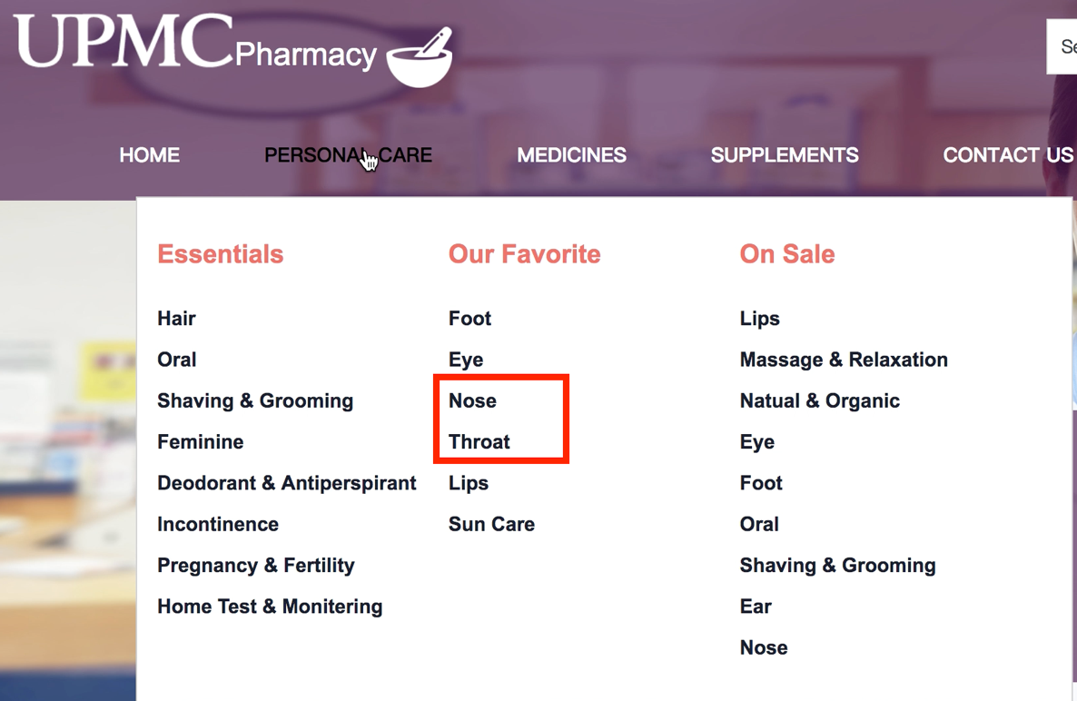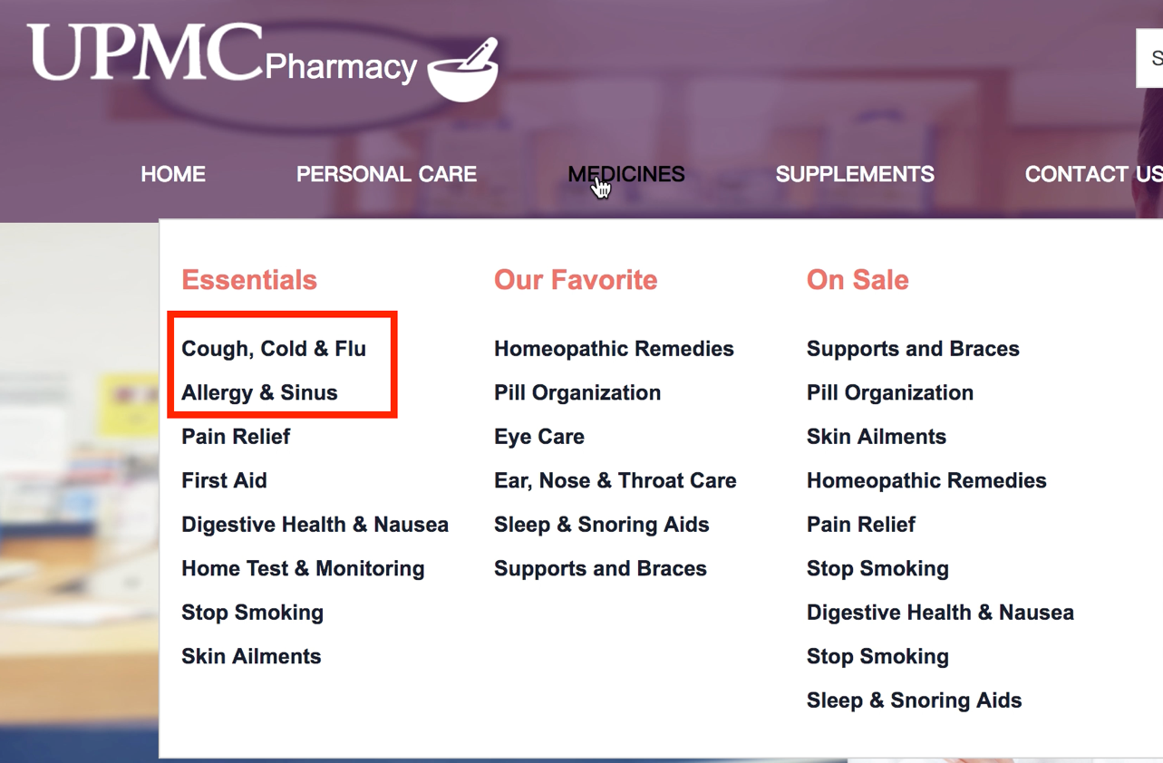

Picture 2:

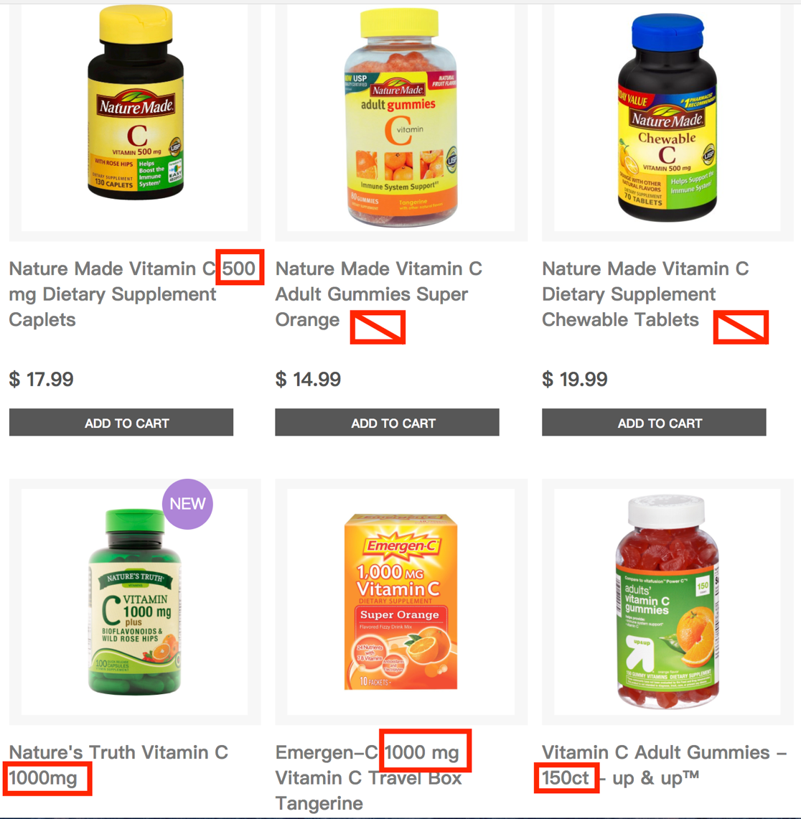

Picture 3:

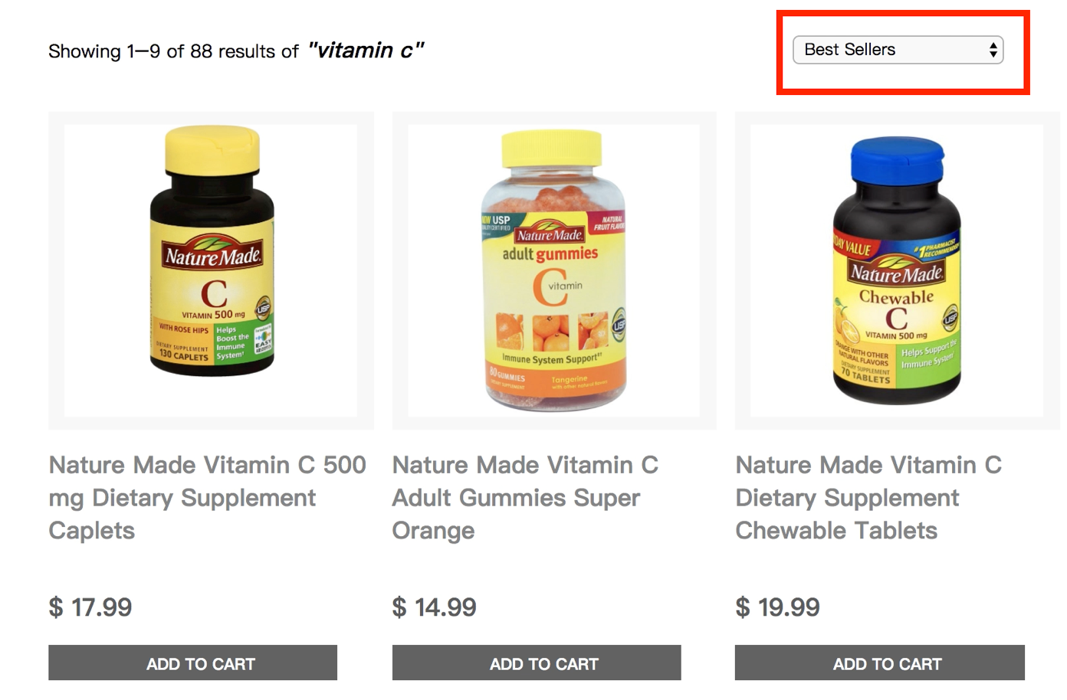

Picture 4:

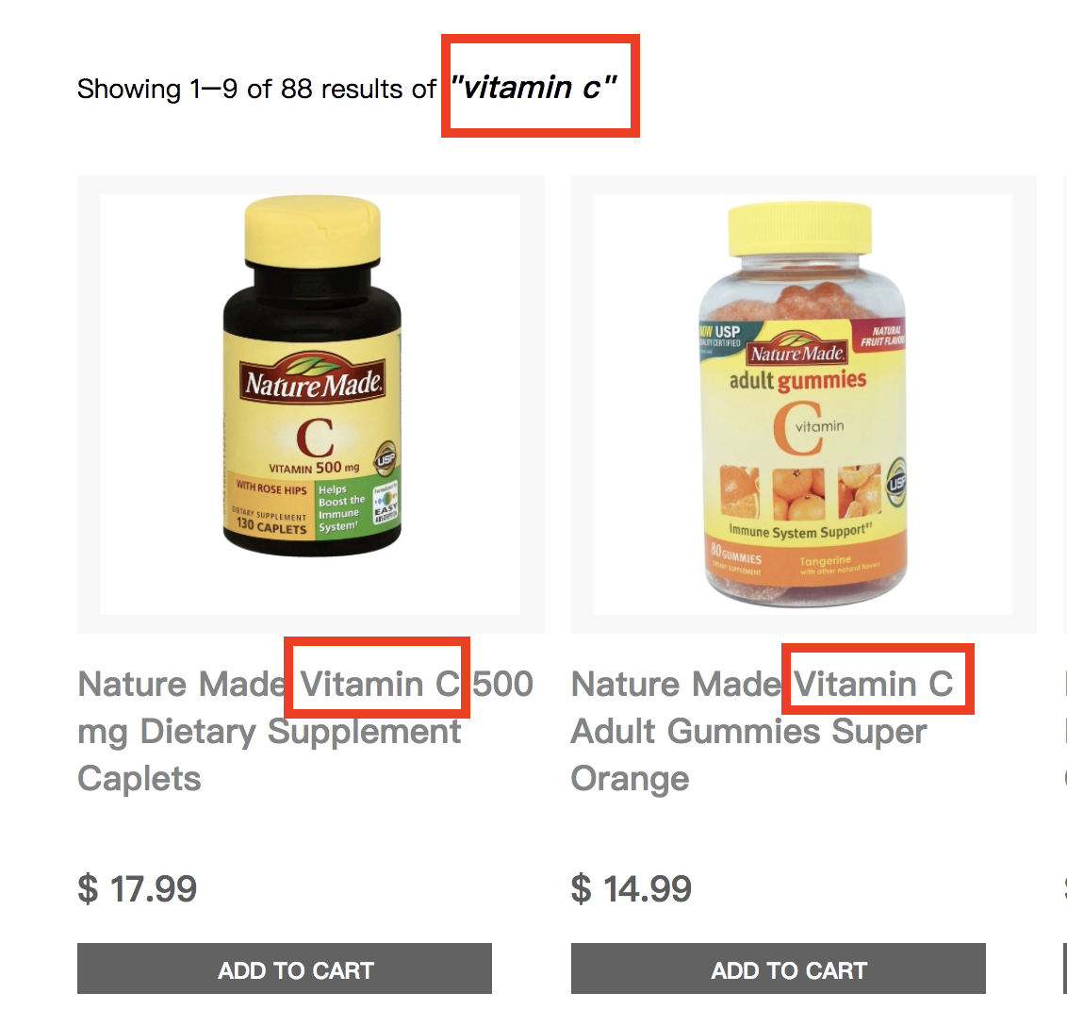

Picture 5:

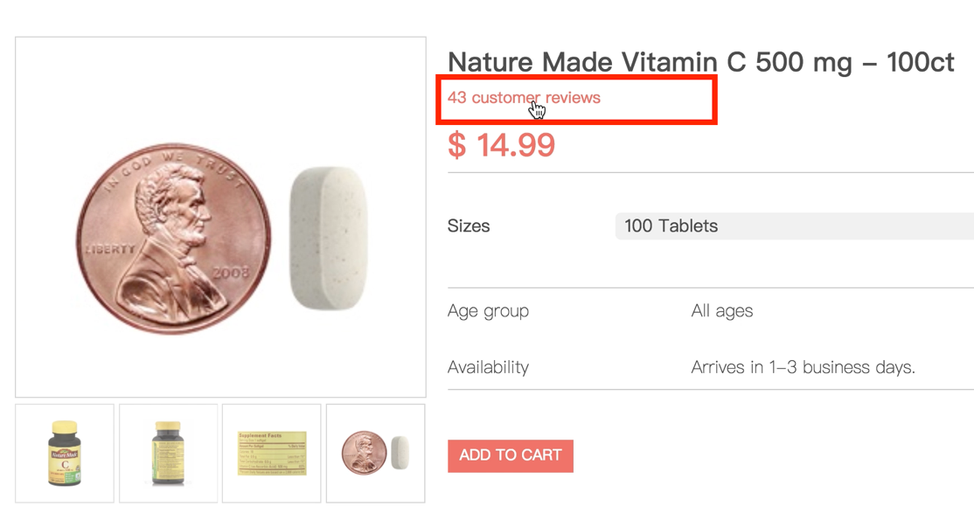

Picture 6:

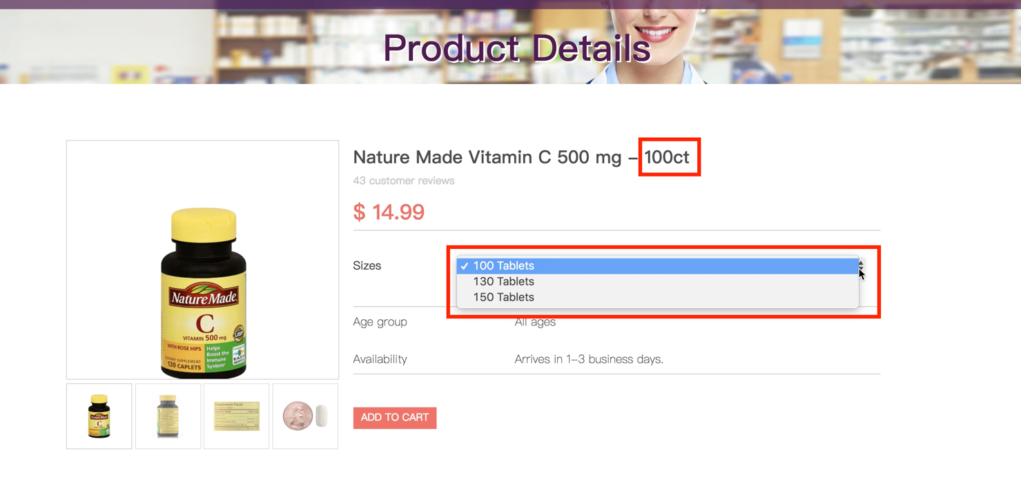

Picture 7:

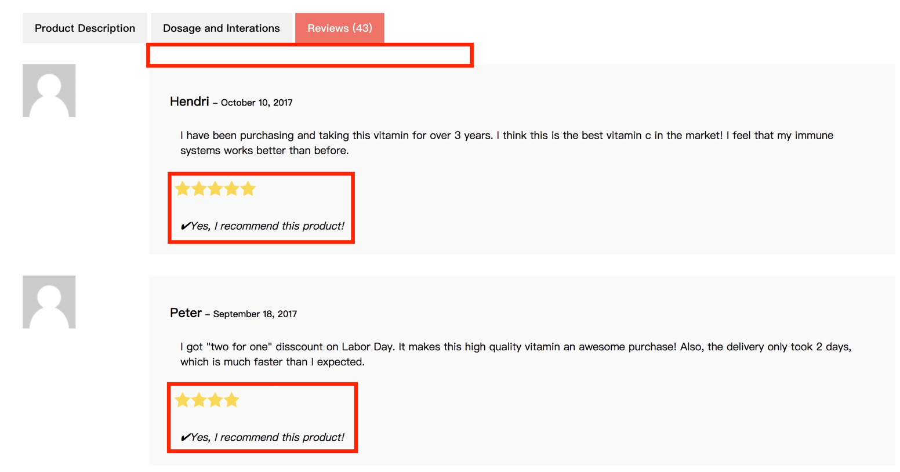

Picture 8:

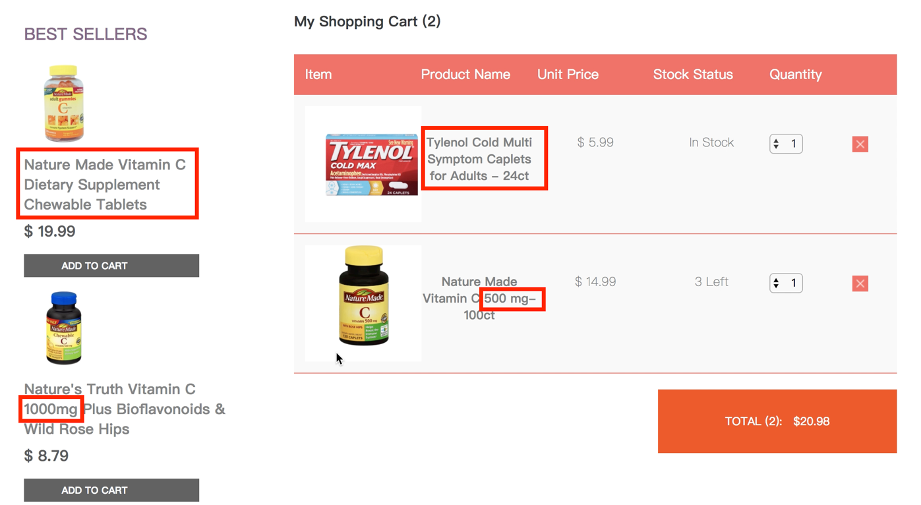

Picture 9:

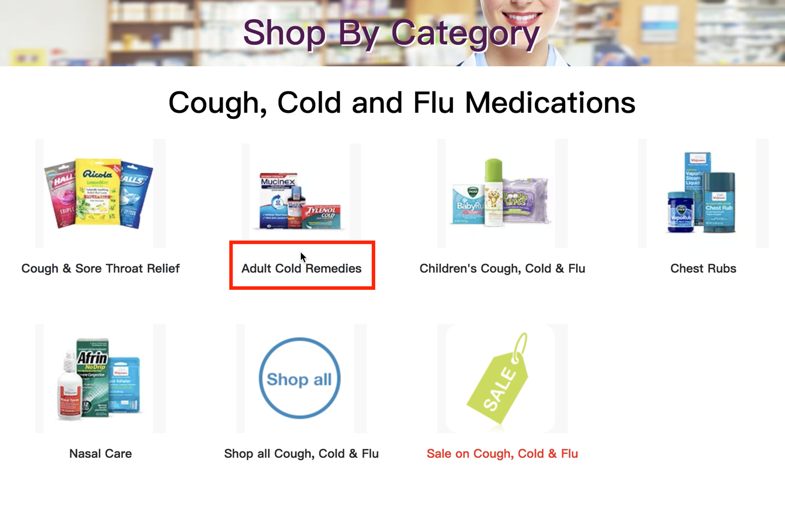

Picture 10:

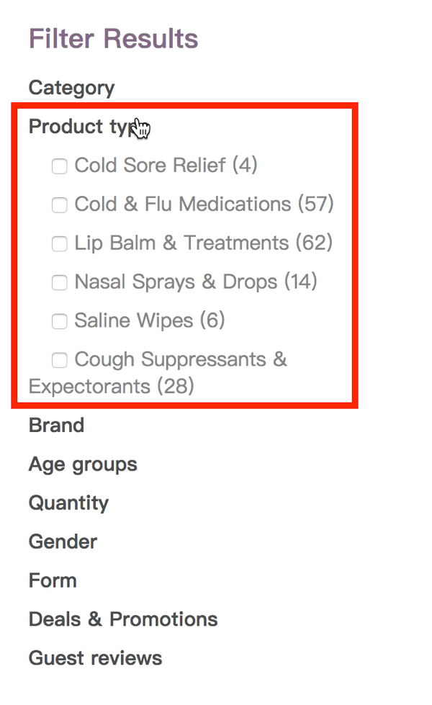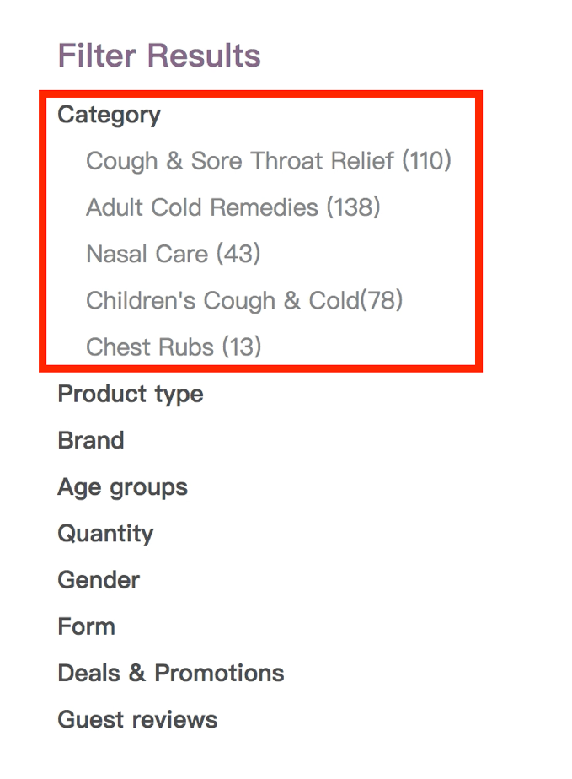

Picture 11:

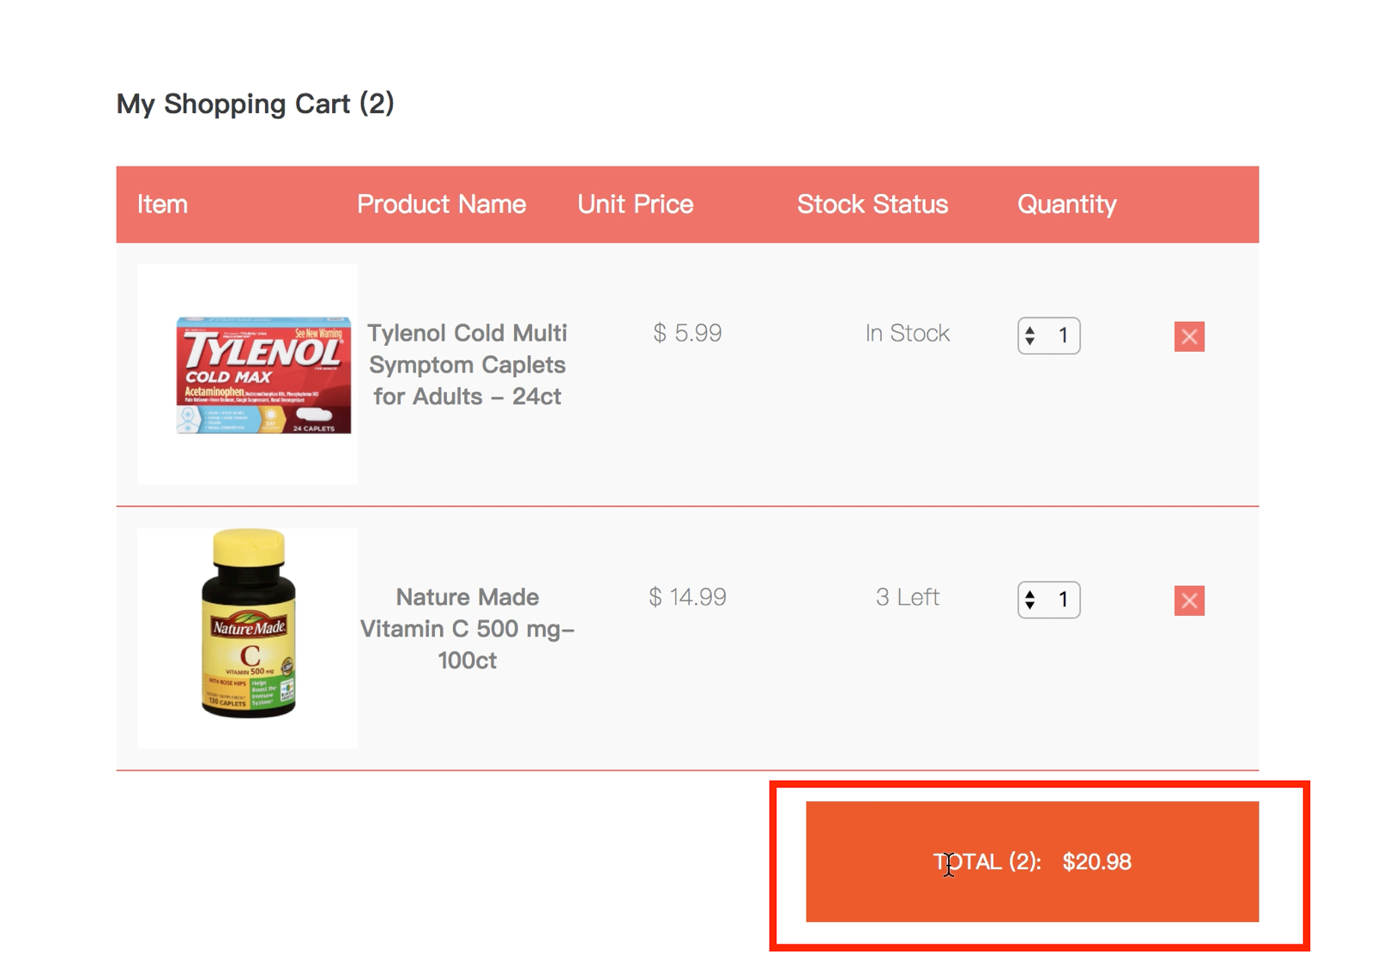

Picture 12:

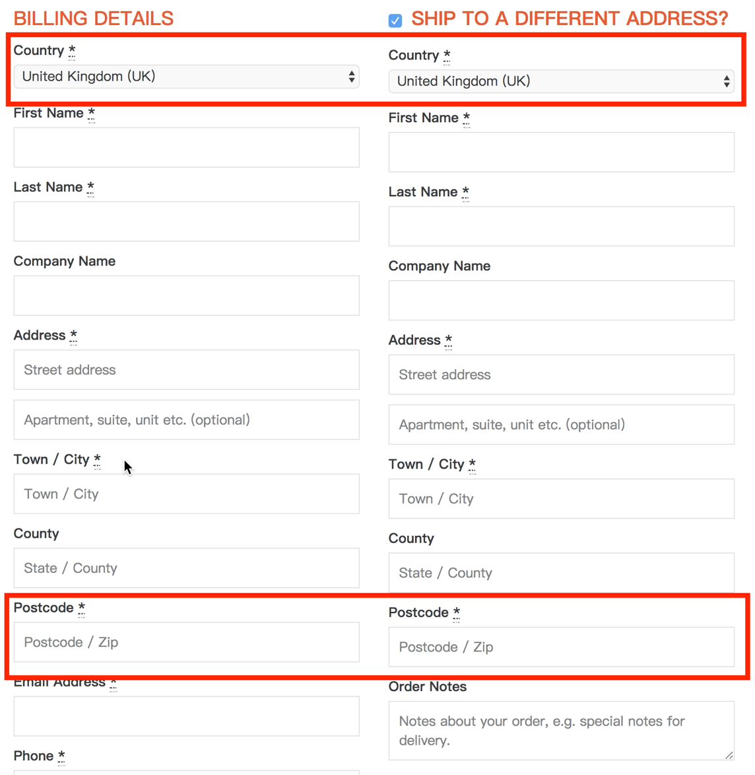

Picture 13:

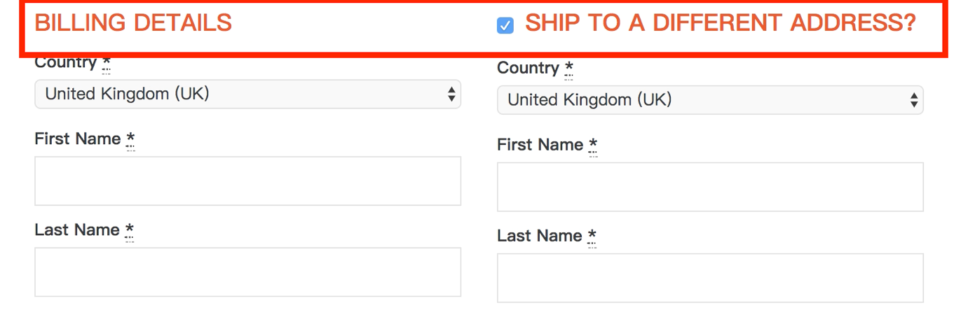

Picture 14:

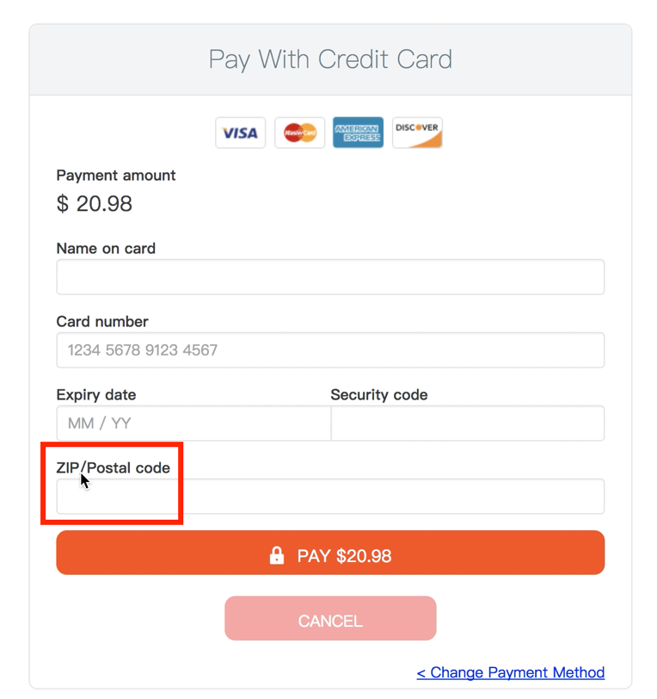

Picture 15:

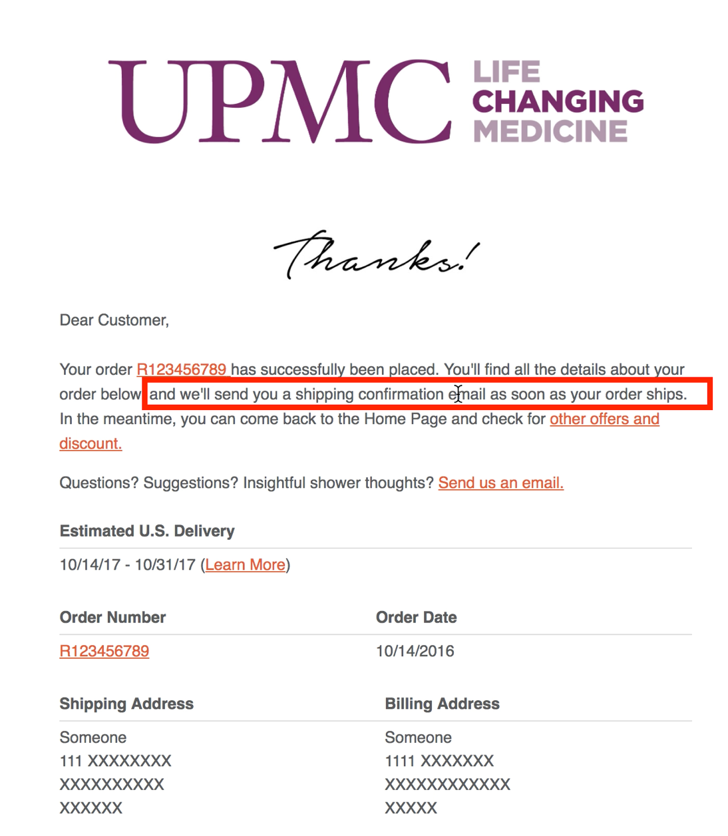

Picture 16:

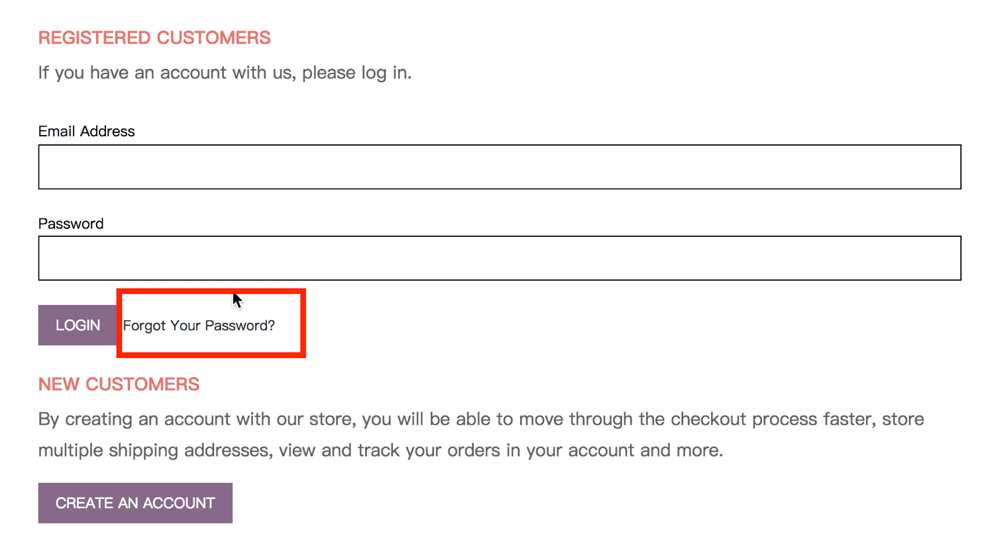

Picture 17:

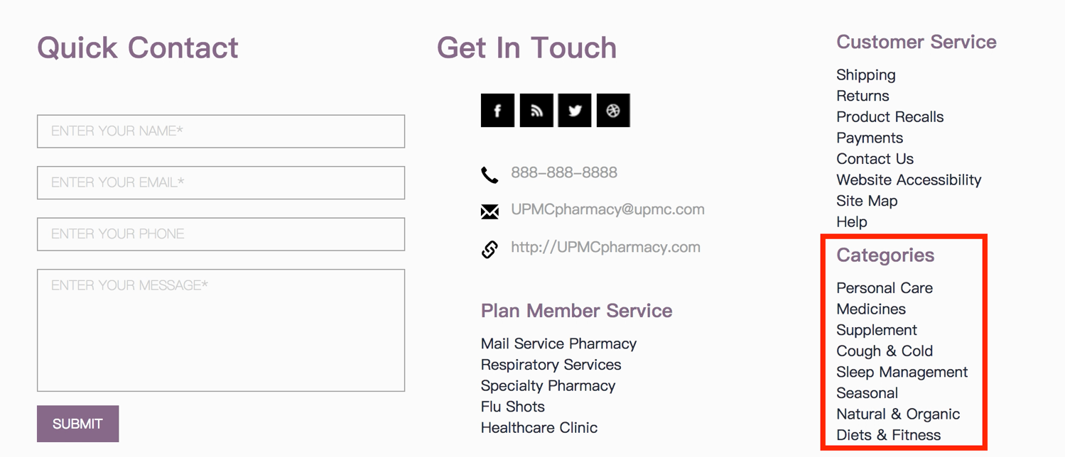

Picture 18:

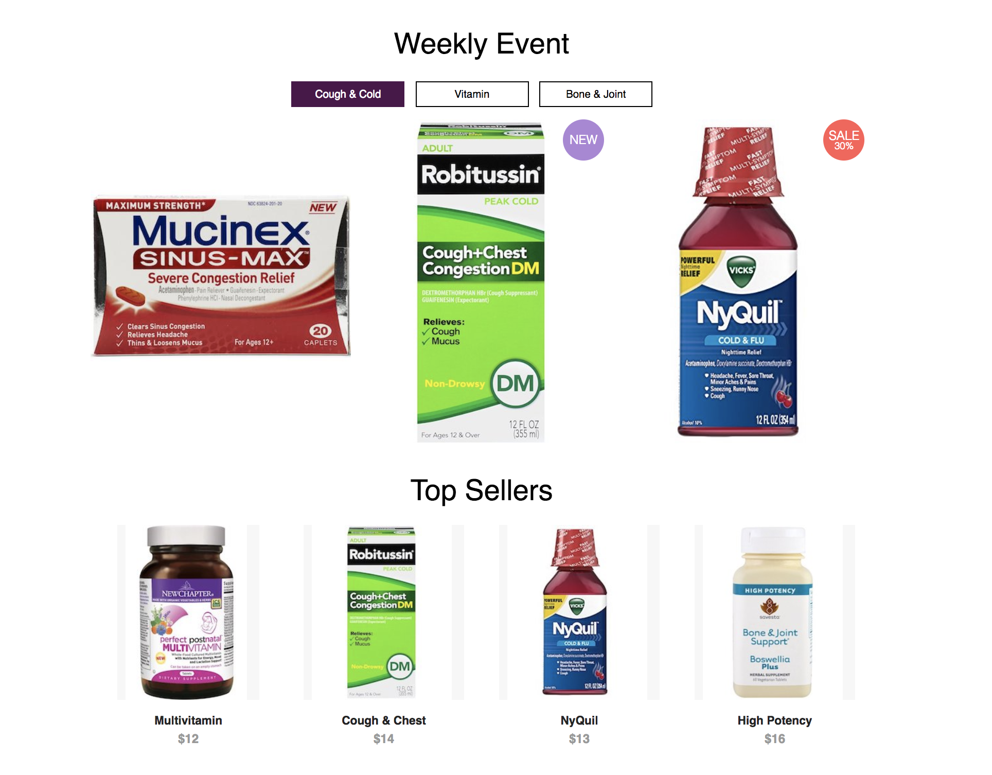

Picture 19:

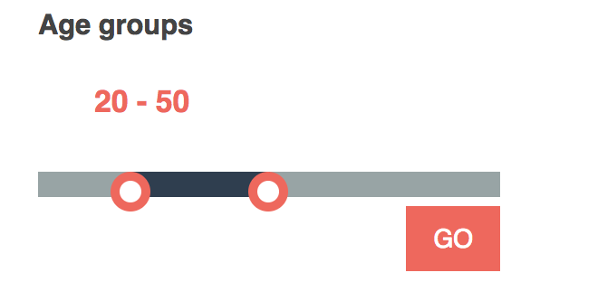

Picture 20:

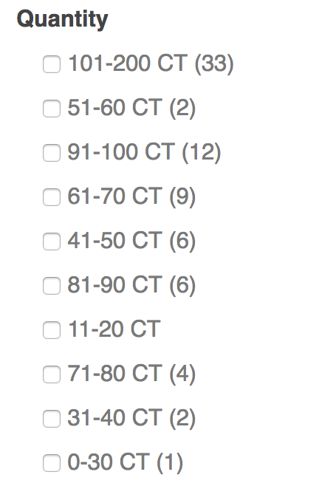

Picture 21:

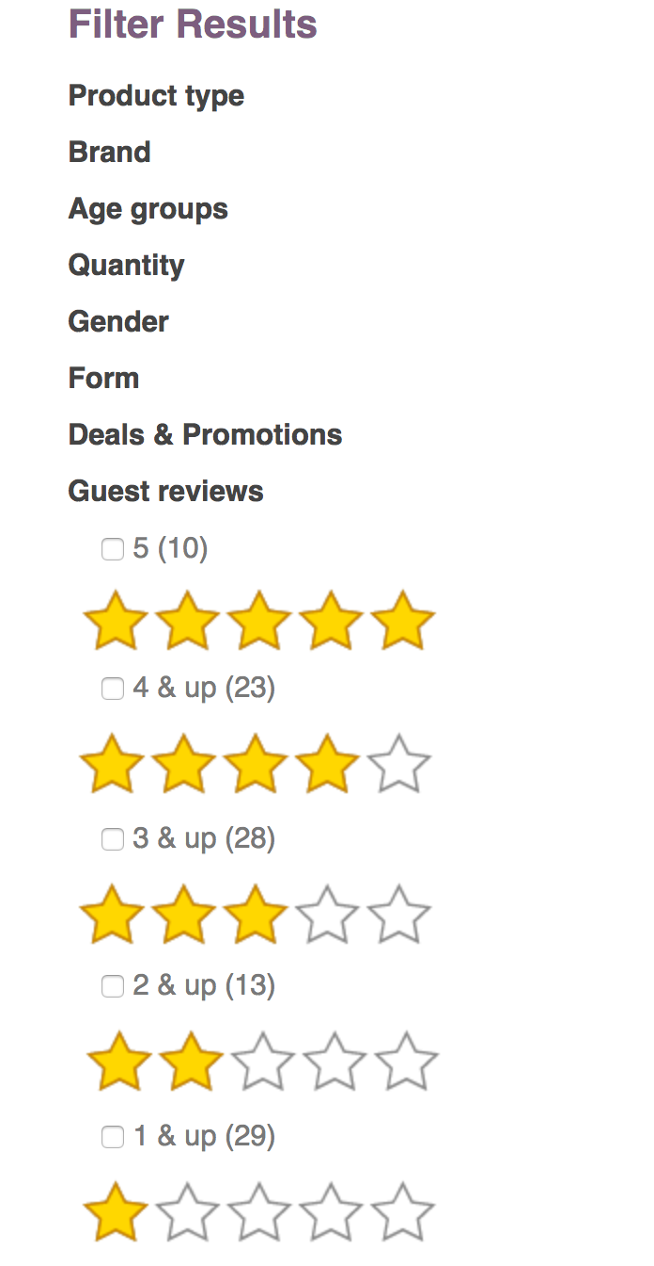

Picture 22:

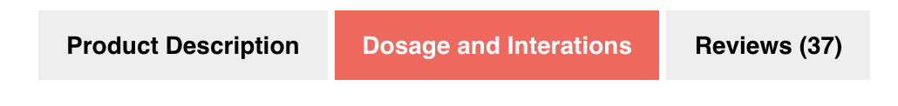

Picture 23:

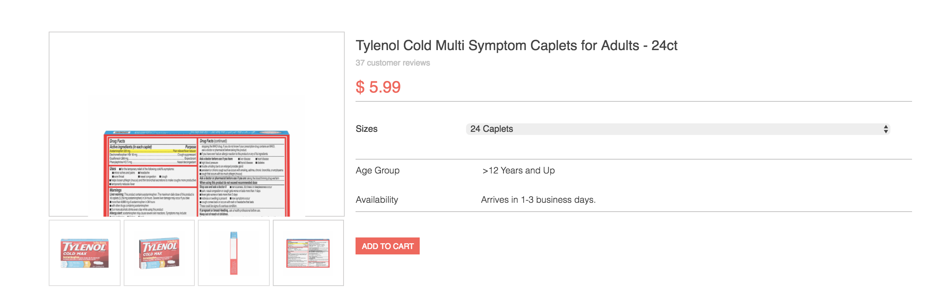

(“Add to Cart” directs to the Cart page)

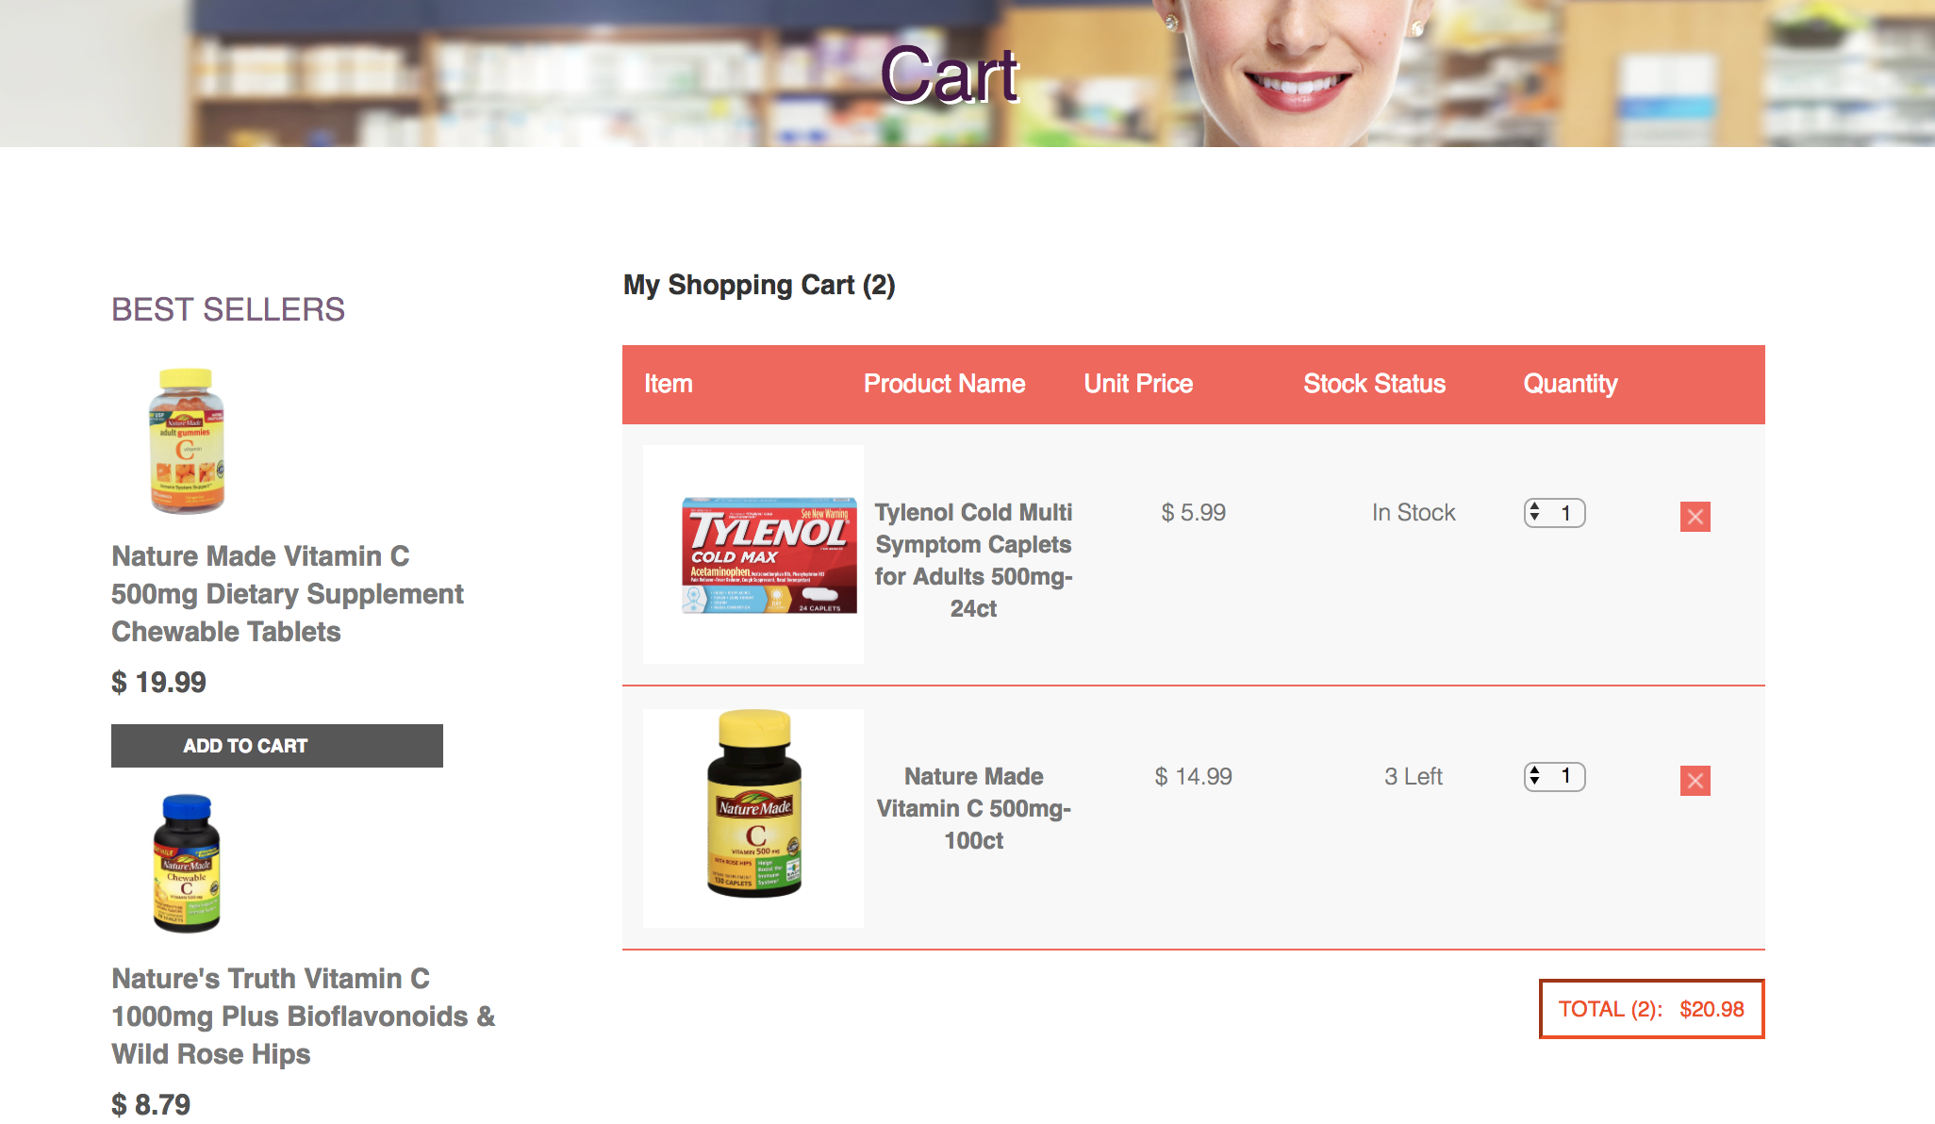

Picture 24:

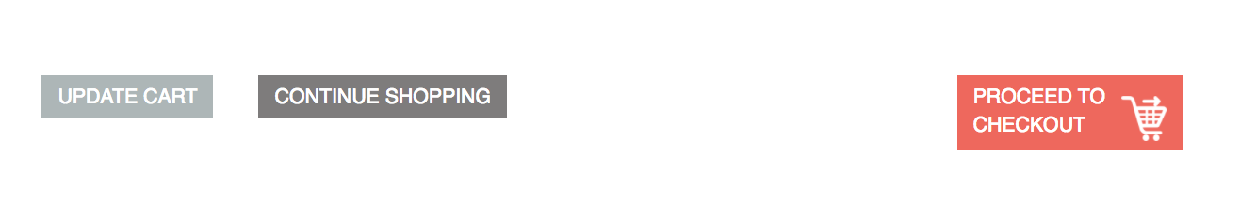

Picture 25:

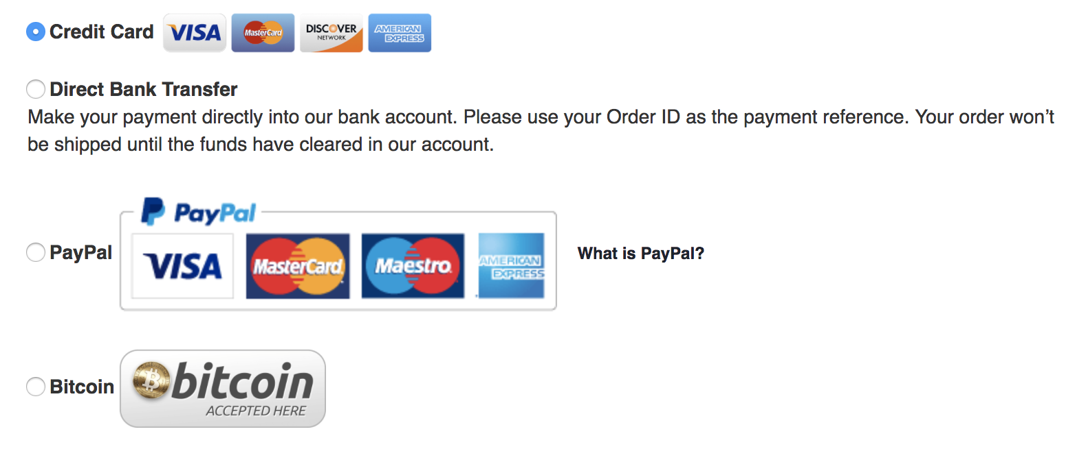

Picture 26:

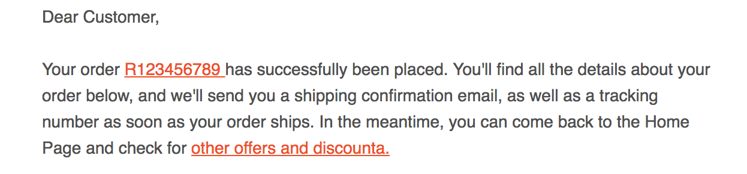

Picture 27:

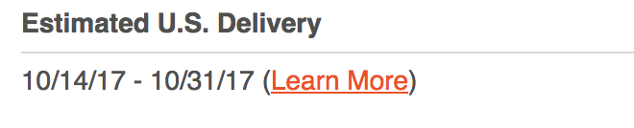

Picture 28:

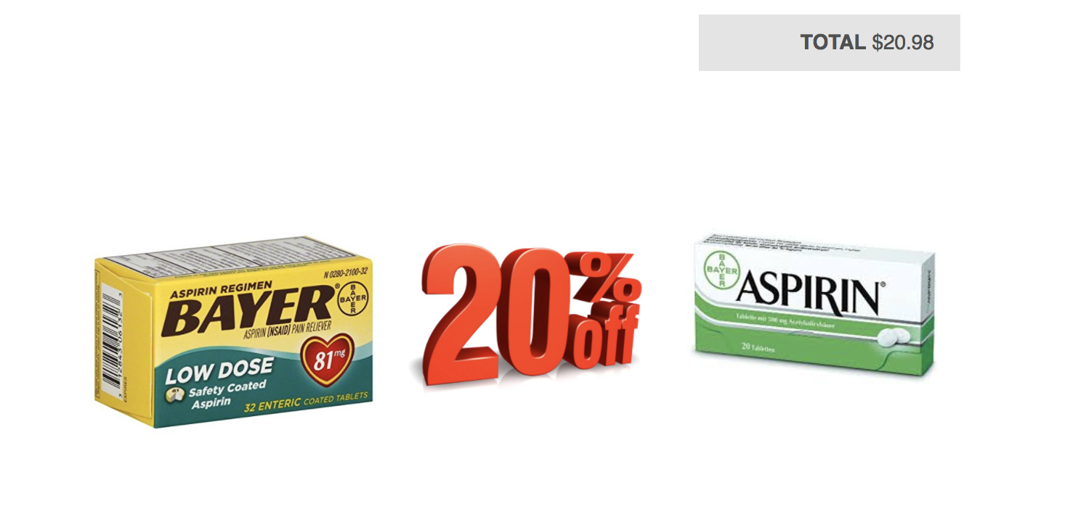

Picture 29:

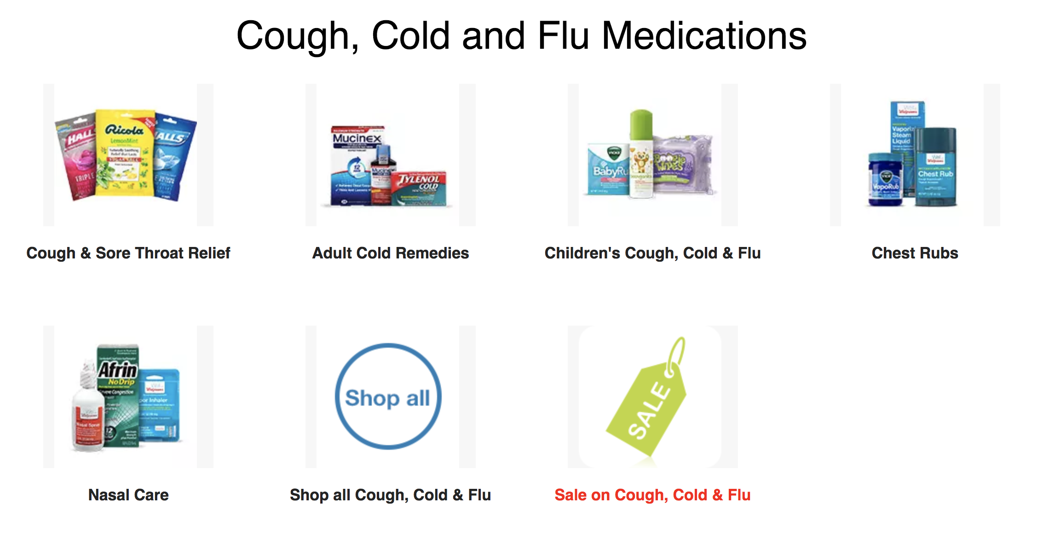

Both have the exact same options enlisted.

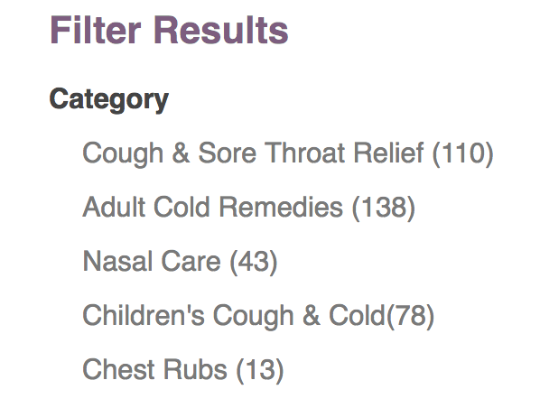

Picture 30:

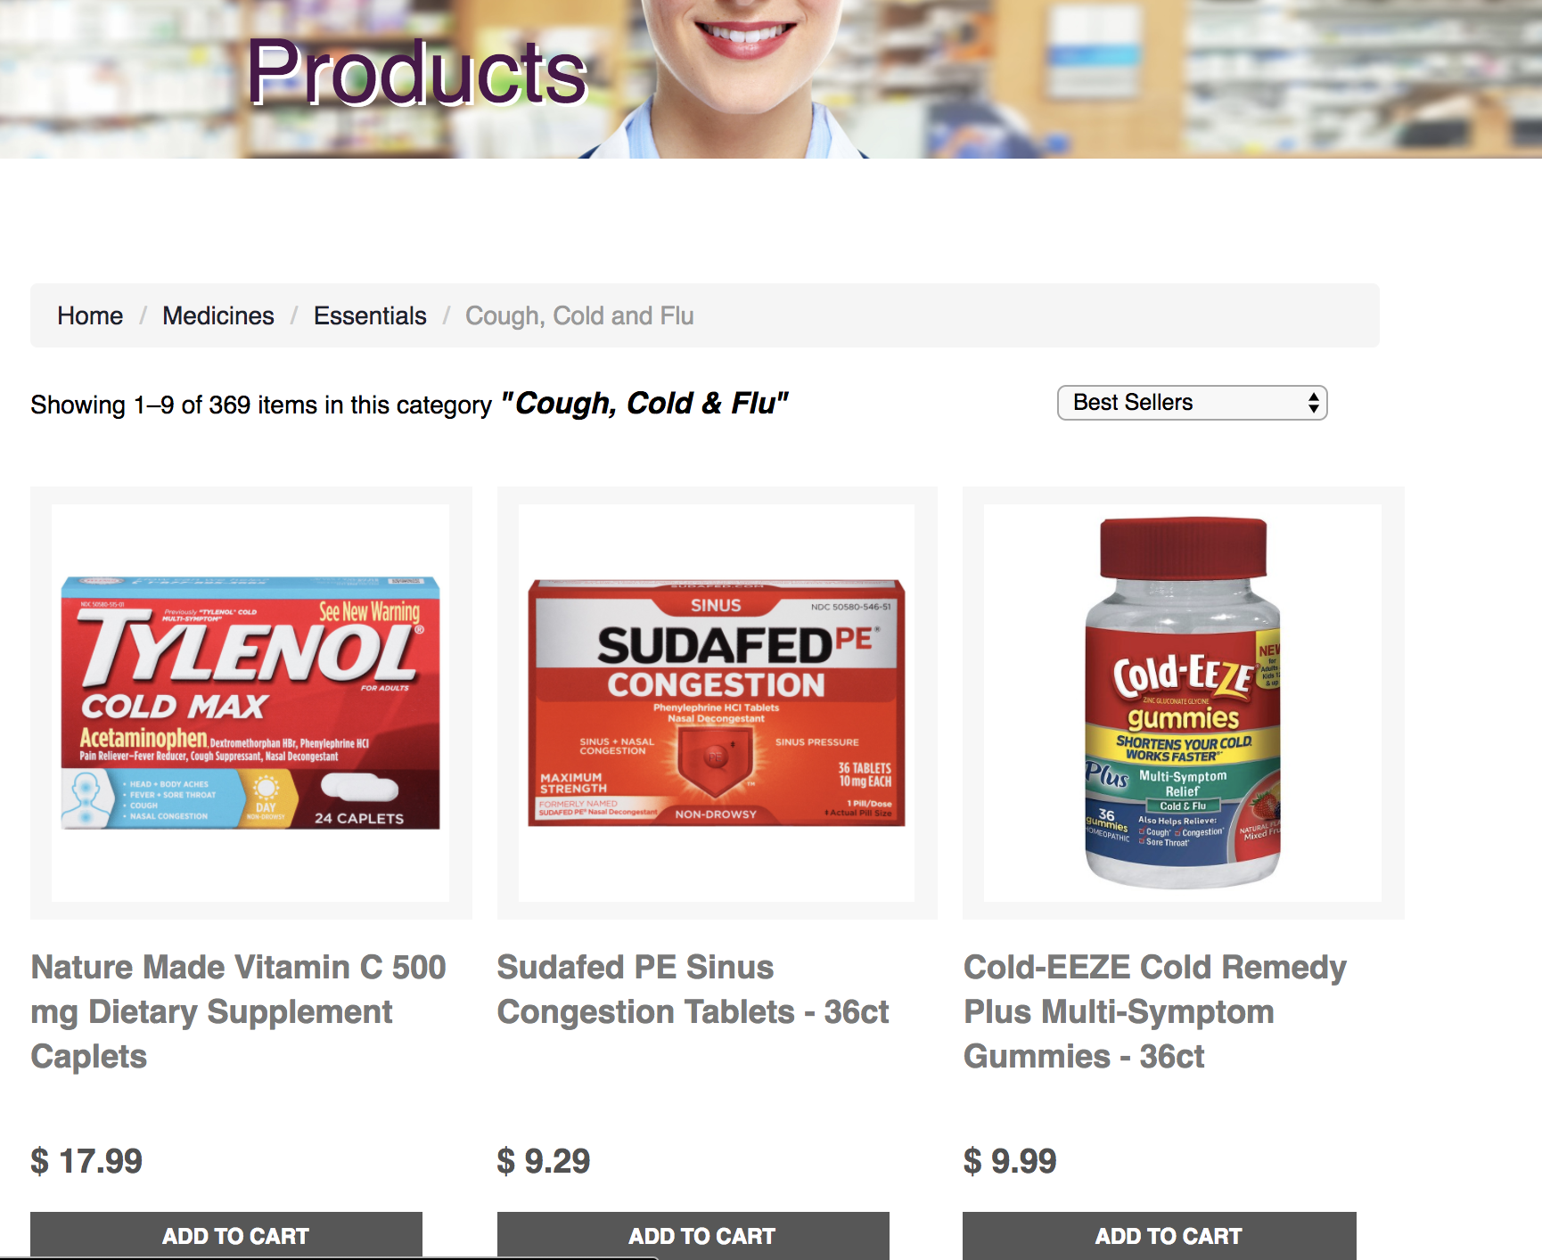

(User wants a search box where “Best sellers” drop-down box is there.)

Picture 31:

